Main Heading: FP5.0 Module-1 Assignments

Batch Name: Summer Internship 2018

Enrollment No:R171217008

SAPID:500061147

Name:Anirudh Chaudhary

Sem: VII(III

Branch:﻿﻿﻿﻿﻿﻿﻿﻿﻿﻿﻿﻿﻿﻿﻿﻿﻿﻿﻿﻿﻿﻿B.Tech Computer Science(DevOps(1st Year-2nd Year))

***Assignment 1***

Create the following using Scratch:

1.

Take a text input from the user as one of the three shape names – "square", "triangle" or "pentagon". Based on

the input, draw either a red square, yellow triangle or black pentagon.

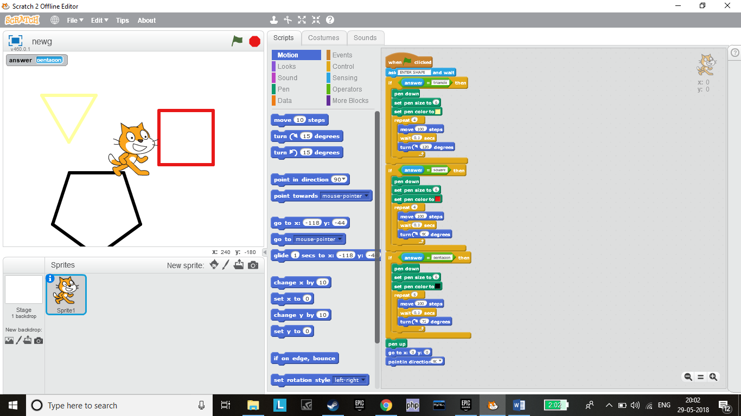

2.

Create the following pattern using Scratch.

Hint: Create 10 squares each with an inclination of 36 degrees from the preceding square

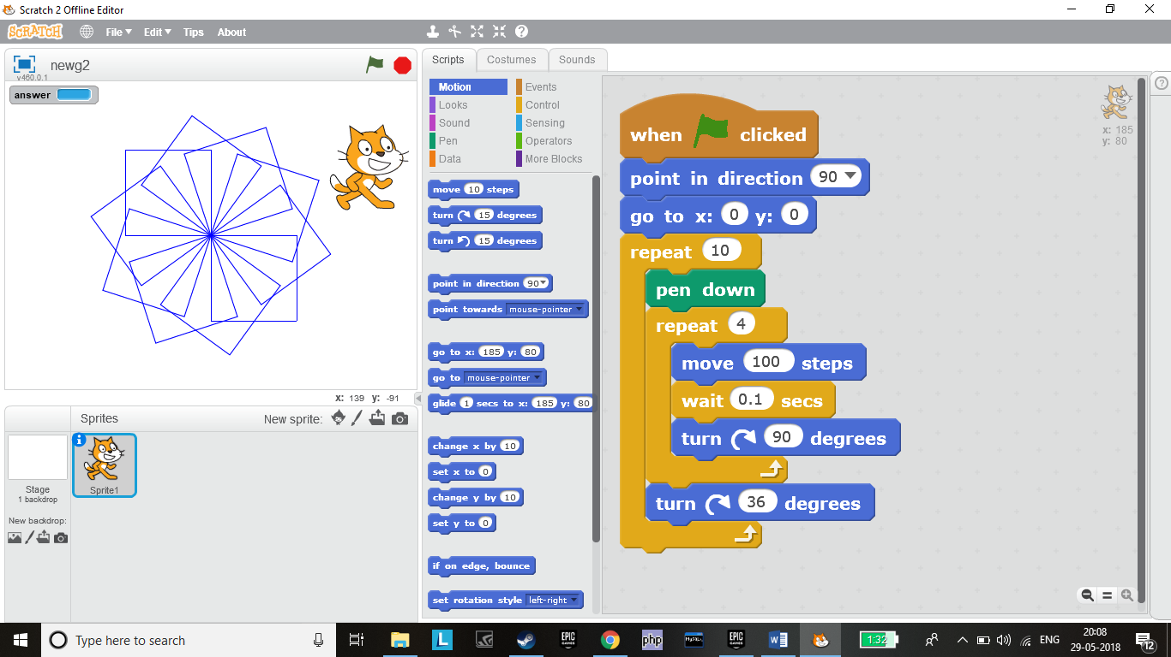

3.

Create or import two Sprites and use your imagination to make them do diﬀerent actions simultaneously. For

example: "A bird is ﬂying and a dog is walking at the same time."

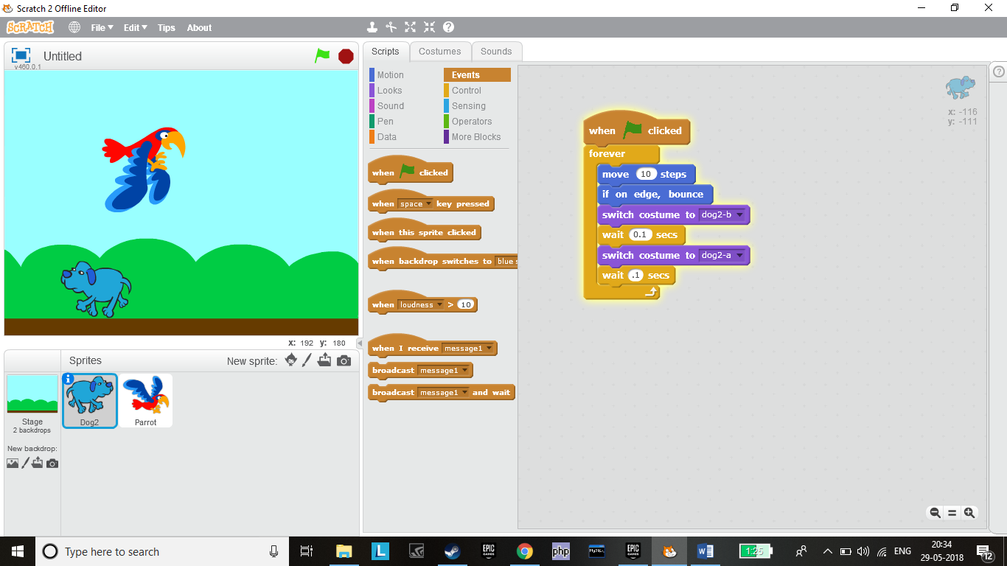

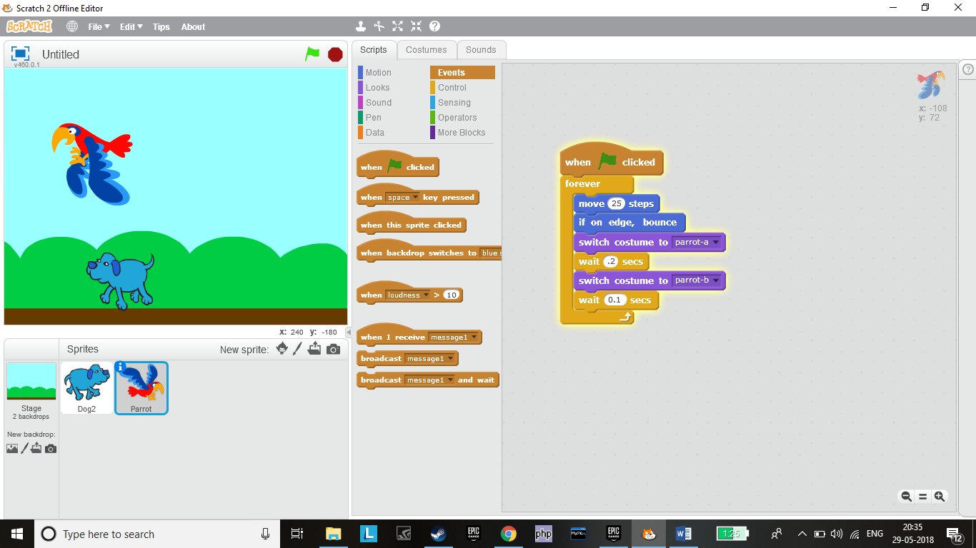

***Assignment 2***

Create ﬂowcharts for the following problems:

1.

Calculate the average of three numbers. If average is greater than or equal to 75, print "Pass", else print "Fail".

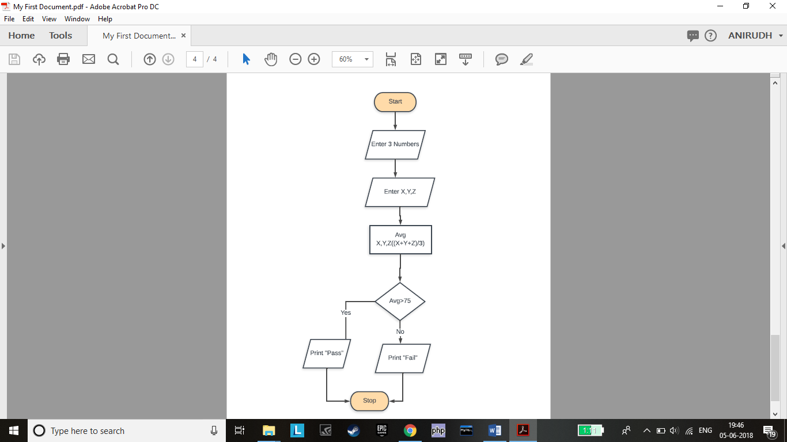

2.

Calculate and print the factorial of a number.

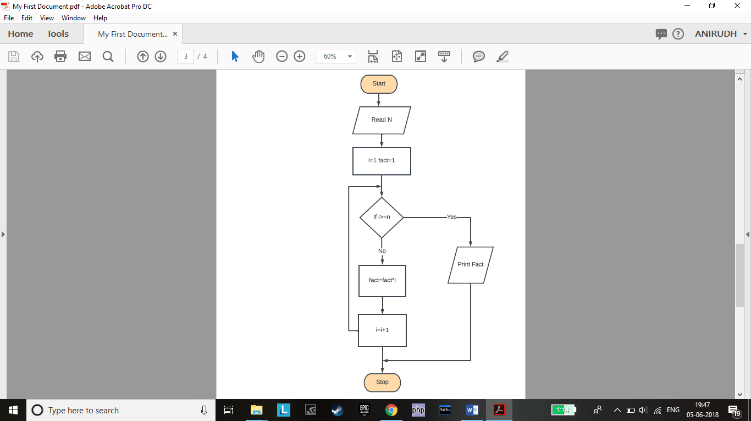

3.

Accept the lengths of three sides of a triangle as input from the user. Based on the input, print if the given

triangle is "Equilateral", "Isosceles" or "Scalene".

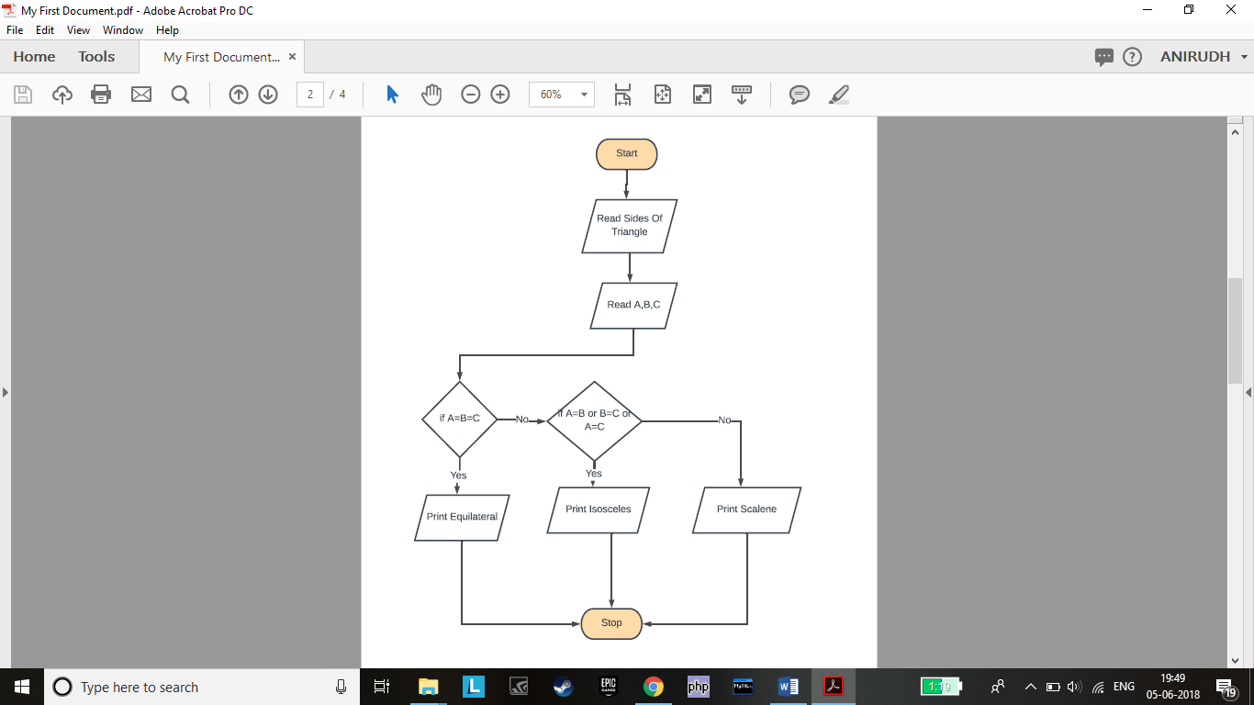

4.

Accept the values of principal amount, rate of interest and number of years as an input from the user. Calculate

and print the simple interest.

Hint - Formula for simple interest:

Simple Interest = (principal amount * rate of interest * number of years)/100

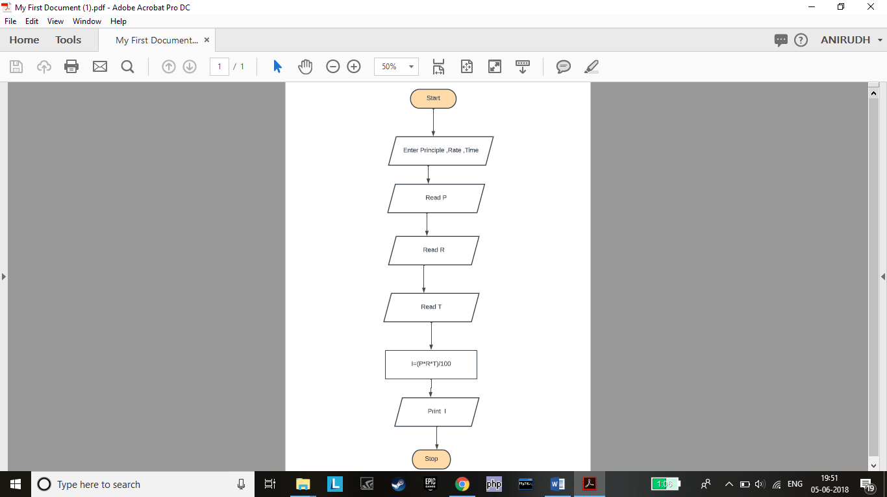

***Assignment 2***

Create ﬂowcharts for the following problems:

1.

Calculate the average of three numbers. If average is greater than or equal to 75, print "Pass", else print "Fail".

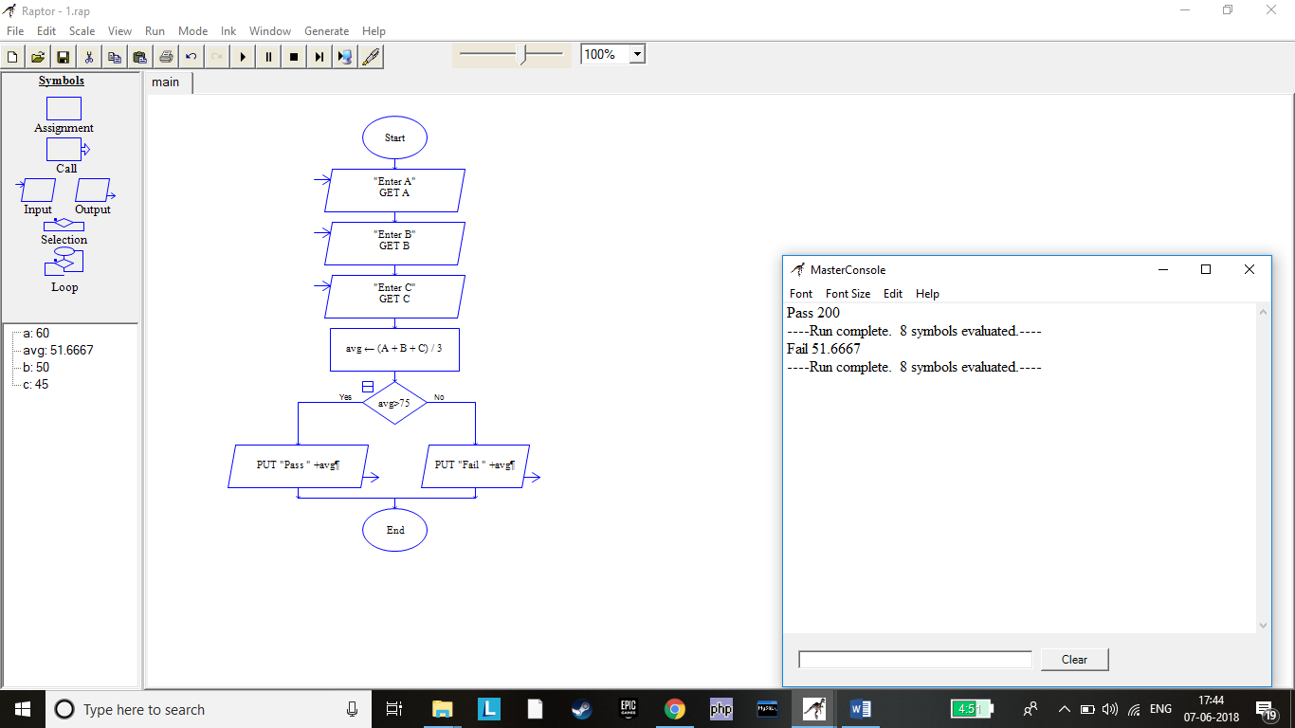

2.Calculate and print the factorial of a number.

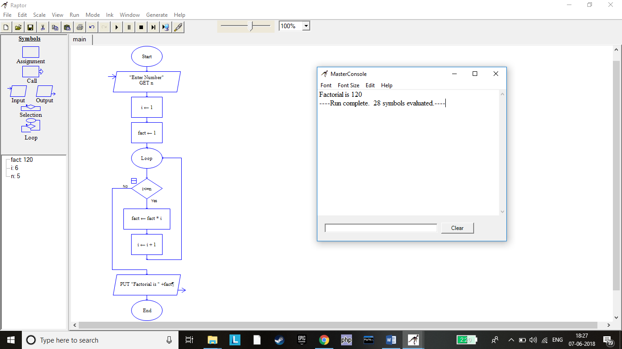

3.

Accept the lengths of three sides of a triangle as input from the user. Based on the input, print if the given

triangle is "Equilateral", "Isosceles" or "Scalene".

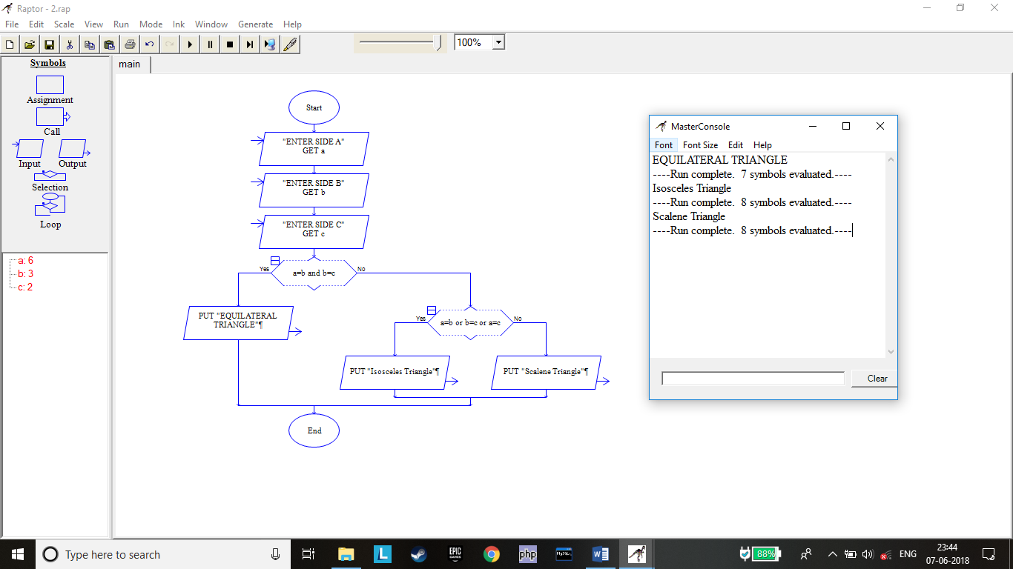

4.Accept the values of principal amount, rate of interest and number of years as an input from the user. Calculate

and print the simple interest.

Hint - Formula for simple interest:

Simple Interest = (principal amount * rate of interest * number of years)/100

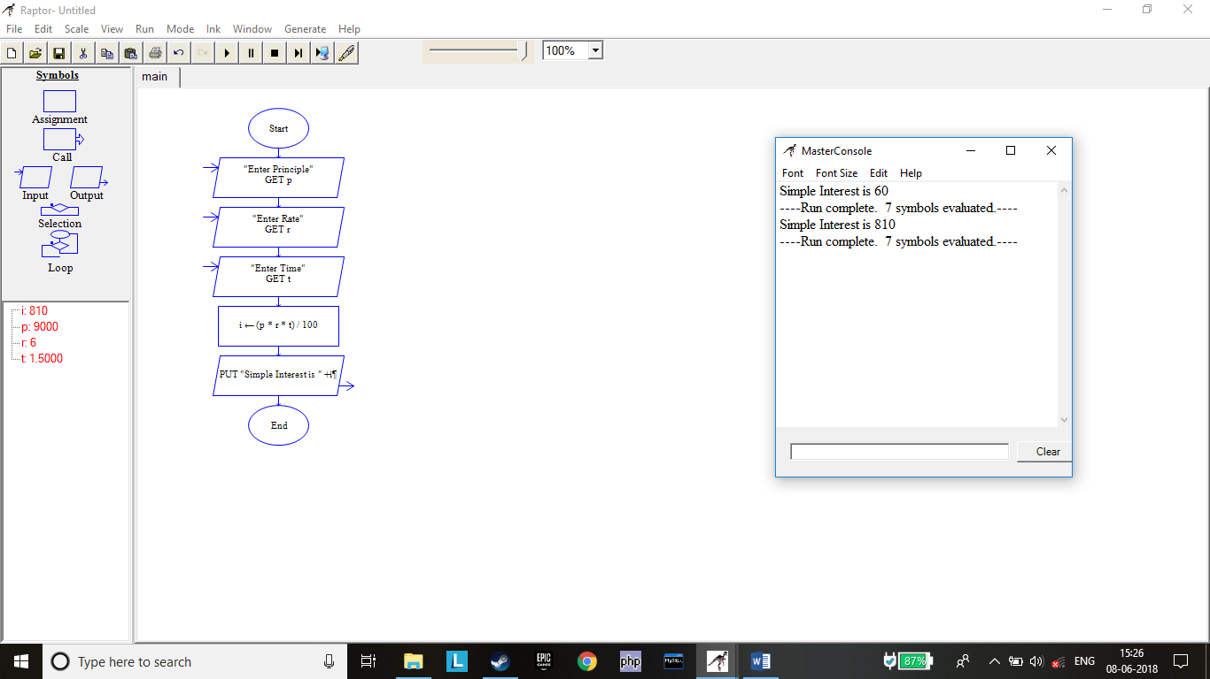

***Assignment 4***

Write Pseudo Code:

1. to check whether a given number is even or odd.

1. START

2. DISPLAY "Enter the Number - "

3. READ number

4. IF number MOD 2 = 0 THEN

              DISPLAY "Number is Even"

     ELSE

              DISPLAY "Number is Odd"

     END IF

5. STOP

2.to print the multiples of 3 between 1 to 20.

1. START

2. number = 1

3. LOOP WHILE number<=20

4. IF number MOD 3 = 0 THEN

              DISPLAY number

     END IF

5. number++

6. END LOOP

7. STOP

3.to ﬁnd factorial of a given number.

1. START

2. DISPLAY "Enter the Number - "

3. READ number

4. fact = 1

5. LOOP FOR i<=number

6. fact = fact * i

7. i++

END LOOP

     8.DISPLAY fact

9. STOP

4.to calculate ‘x’ to the power of ‘n’ using a while loop.

•Assume both ‘x’ and ‘n’ are positive whole numbers

1. START

2. DISPLAY "Enter the Number - "

3. READ number

4. DISPLAY “Enter Power”

5. READ power

6. result = 1

7. LOOP FOR power > 0

8. result = result * number

9. power--

END LOOP

     10.DISPLAY result

11. STOP

***Assignment 5***

Open the Python IDLE and execute the following commands. Observe the output.

1)10 + 15

2)print("Hello World")

3)45 - 34

4)8 * 2

5)print("Rahul's age is", 45)

6)print("I have", 10, "mangoes and", 12, "bananas")

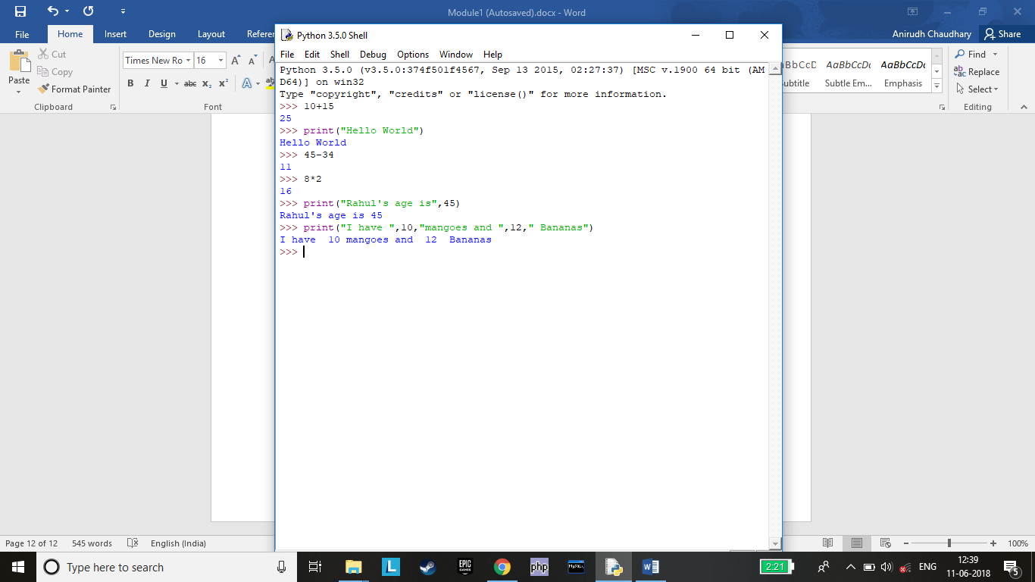

***Assignment 6***

Open Python IDLE and execute the following commands. Observe the output.

1.emp_number = 1233

2.print("Employee Number:", emp_number)

3.emp_salary = 16745.50

4.emp_name = "Jerry Squaris"

5.print("Employee Salary and Name:", emp_salary, emp_name)

6.emp_salary = 23450.34

7.print("Updated Employee Salary:", emp_salary)

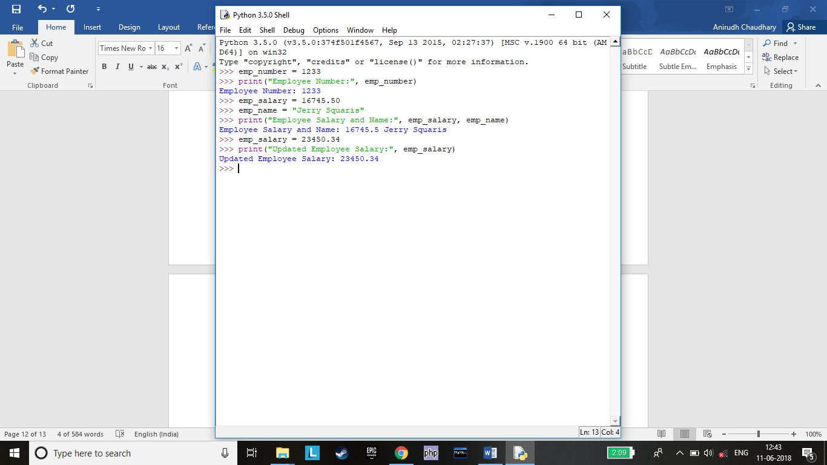

***Assignment 7***

Execute the following Python statements in IDLE and observe the output:

• customer_id = 101

•type(customer_id)

•customer_name = "John"

•type(customer_name)

•bill_amount = 675.45

•type(bill_amoun)

•x = 5.3 + 0.9j

•type(x)

•print(customer_id, customer_name, bill_amount)

•print(x.real)

•print(x.imag + 3)

•Flag = True

•type(Flag)

•y = "False"

•type(y)

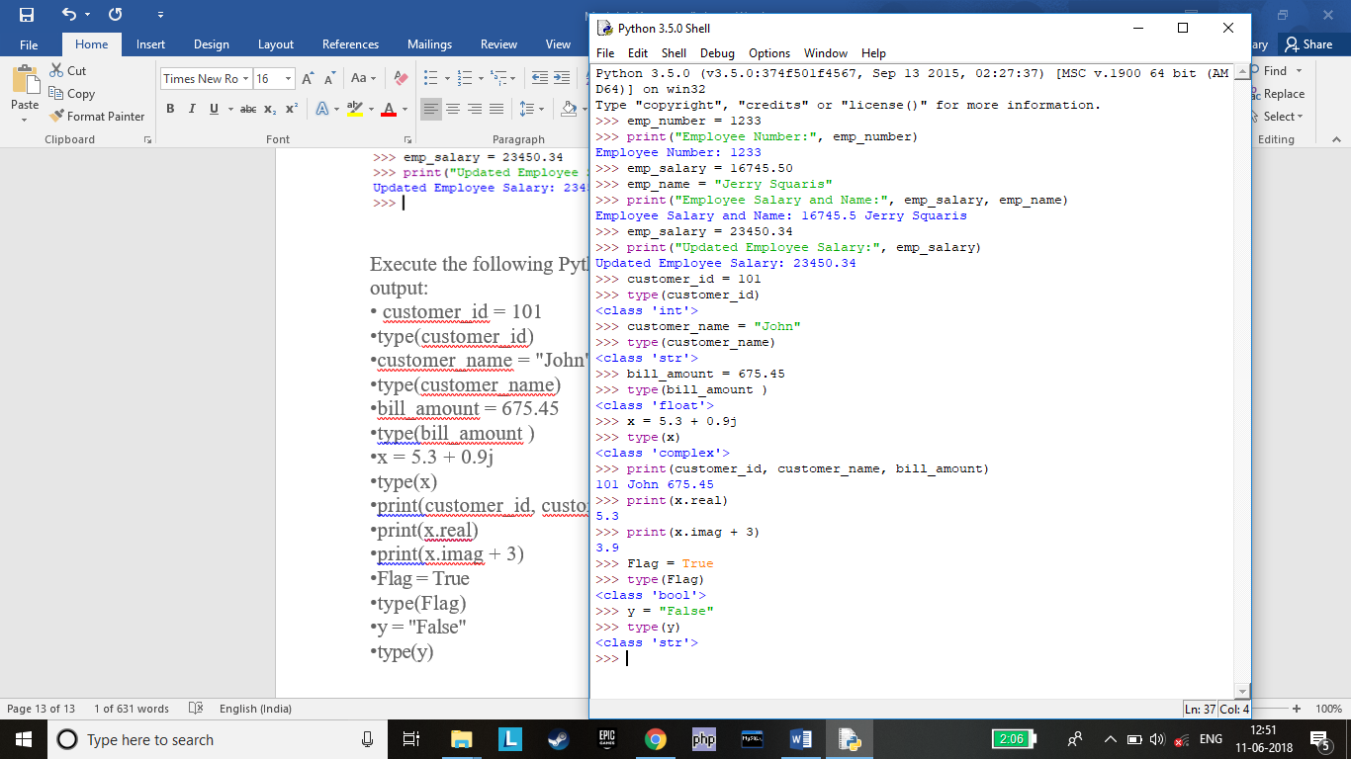

***Assignment 8***

In a retail application, shopkeeper wants to keep a track of following details of a customer. Sample values are provided.

•bill_id = 101

•customer_id = 1001

•customer_name = "Rahul"

•if_minor = False

•bill_amount = 2000.50

Write a python program to store the details and display them.

#

bill_id = 101

customer_id = 1001

customer_name = "Rahul"

if_minor = False

bill_amount = 2000.50

print(“Customer ID is “,customer_id)

print(“Customer Name is “,customer_name)

print(“Customer Bill ID is “,bill_id)

print(“Customer Bill Amount is “,bill_amount)

print(“Customer is minor?“,if_minor)

#

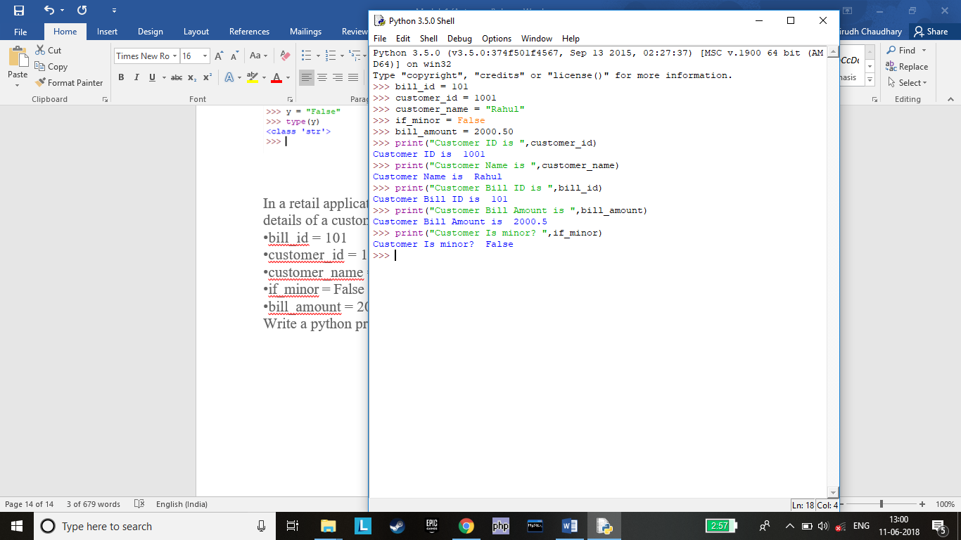

***Assignment 9***

Execute the following commands and observe the usage of diﬀerent types of commenting styles.

i = 10 # creates an integer variable. This is a single line comment.

print("i =", i) # prints 10

'''

Below code creates a Boolean variable in Python

(This is a multiple line comment)

'''

s = True

print("s =", s) #prints True, Here, s is a Boolean variable with value True

"""

Below code assigns string data to variable 's'. Data type of variable can change during execution,

Hence, Python supports Dynamic Semantics.

(This is multi-line comment used for documentation)

"""

s = 24

print("s =", s) #prints 24, Here, s is changed to integer data type with value 24

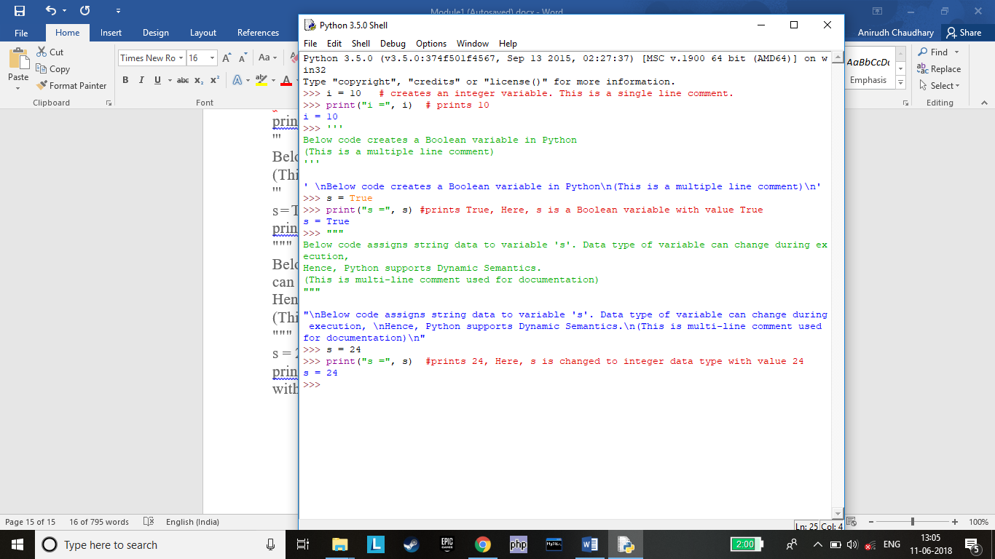

***Assignment 10***

Write a Python program for the following requirements:

•Prompt the user to input two numbers num1 and num2

•Increment num1 by 4 and num2 by 6

•Find and print the sum of new values of num1 and num2

Hint – Use type casting for converting the input into an integer.

#

>>> num1=int(input("ENTER NUM 1 \n"))

>>> num2=int(input("ENTER NUM 2 \n"))

>>> num1+=4

>>> num2+=6

>>> print("New Value of NUM 1=%2d \n New Value Of NUM 2=%2d \n Sum Is %3d"%(num1,num2,num1+num2))

#

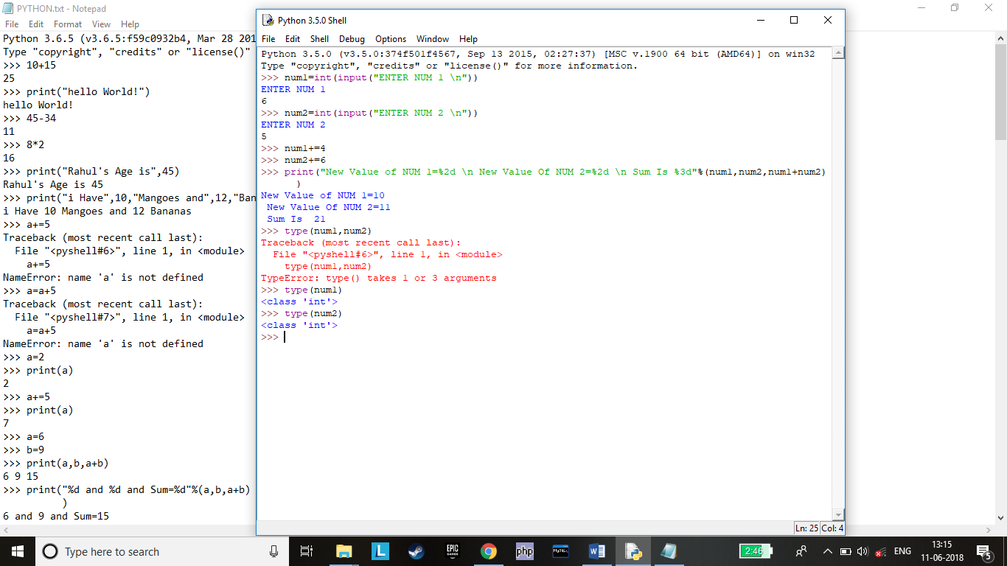

***Assignment 11***

1) Consider two variables 'a' and 'b' in Python such that a = 4 and b = 5. Swap the values of 'a' and 'b' without using a temporary variable. Print the values of 'a' and 'b' before and after swapping.

#

a=4

b=5

print("Value of A=%d and B=%d"%(a,b))

a,b=b,a

print("Swapped Value of A=%d and B=%d"%(a,b))

#

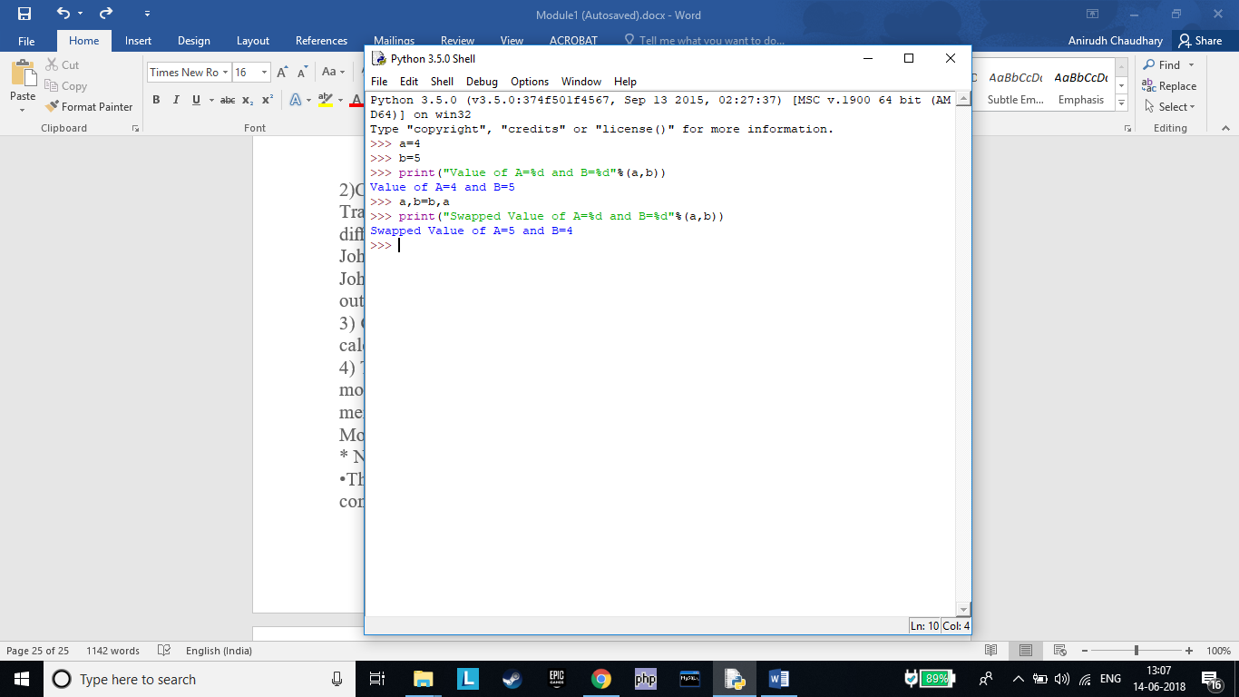

2)Consider the scenario of processing marks of a student in ABC Training Institute. John, the student of ﬁfth grade takes exams in three diﬀerent subjects. Create three variables to store the marks obtained by John in three subjects. Find and display the average marks scored by John. Now change the marks in one of the subjects and observe the output. Did the value of average change?

#

maths=96

eng=76

hindi=83

avg=(maths+eng+hindi)/3

print("Average marks is ",avg)

eng=84

print("Average marks is ",avg)

#

Value Of Average Did Not Change!!

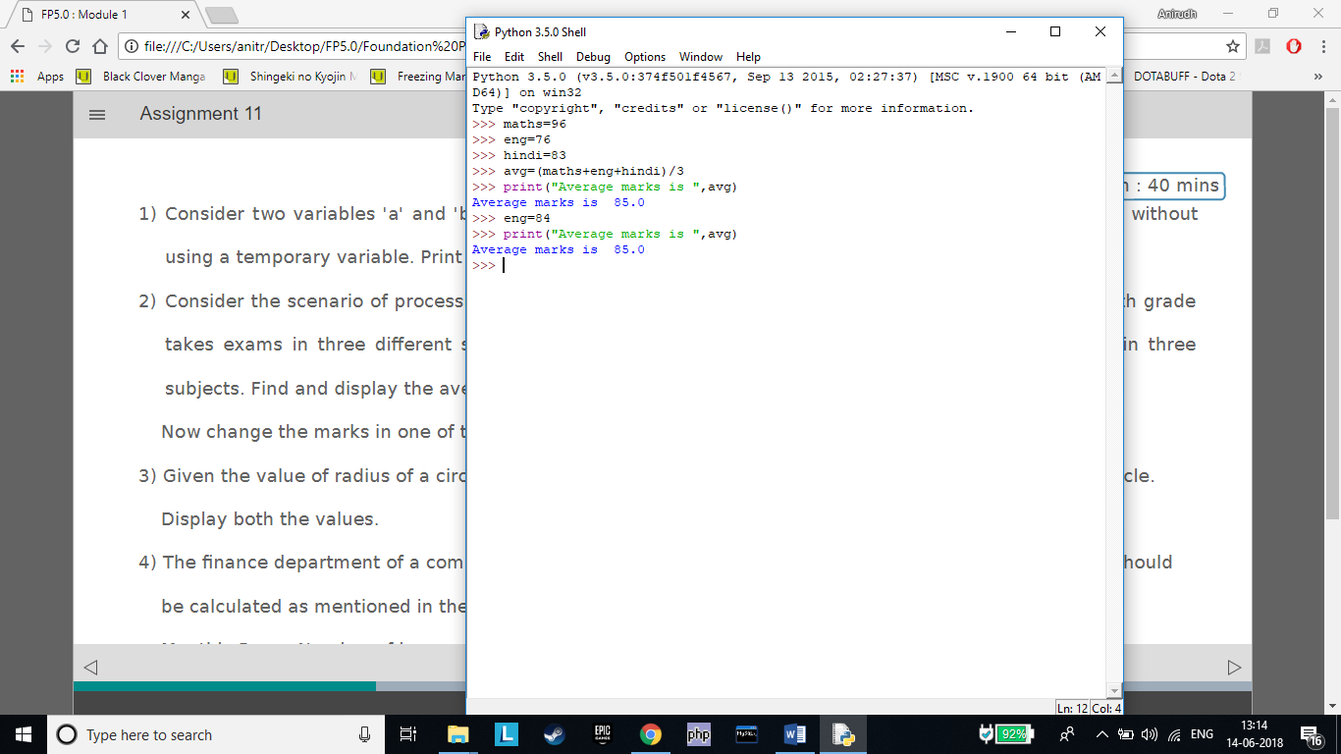

3) Given the value of radius of a circle, write a Python program to calculate the area and perimeter of the circle. Display both the values.

#

r=float(input("ENTER RADIUS OF CIRCLE \n"))

ar=3.14*r**2

peri=2*3.14*r

print("AREA OF CIRCLE IS %d Sq.cm"%ar)

print("PERIMETER OF CIRCLE IS %d cm"%peri)

#

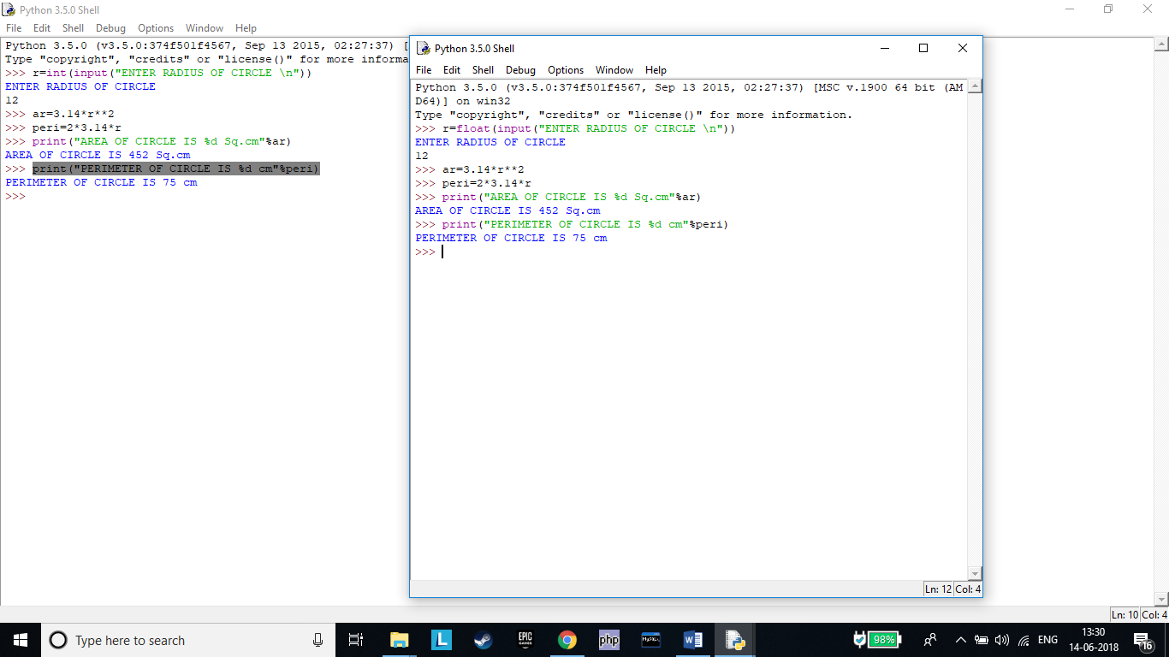

4) The ﬁnance department of a company wants to compute the monthly pay of its employees. Monthly pay should be calculated as mentioned in the formula below. Display all the employee details.

Monthly Pay = Number of hours worked in a week * Pay rate per hour * No. of weeks in a month

•The number of hours worked by the employee in a week should be considered as 40

•Pay rate per hour should be considered as Rs.400

•Number of weeks in a month should be considered as 4

#

name=str(input("ENTER NAME \n"))

no_hours=40

rate=400

no_weeks=4

month_pay=no_hours*rate*no_weeks

print("No. Of Hours =",no_hours)

print("No. Of Weeks=",no_weeks)

print("Pay Rate Per hour =",rate)

print("Monthly Pay=",month_pay)

#

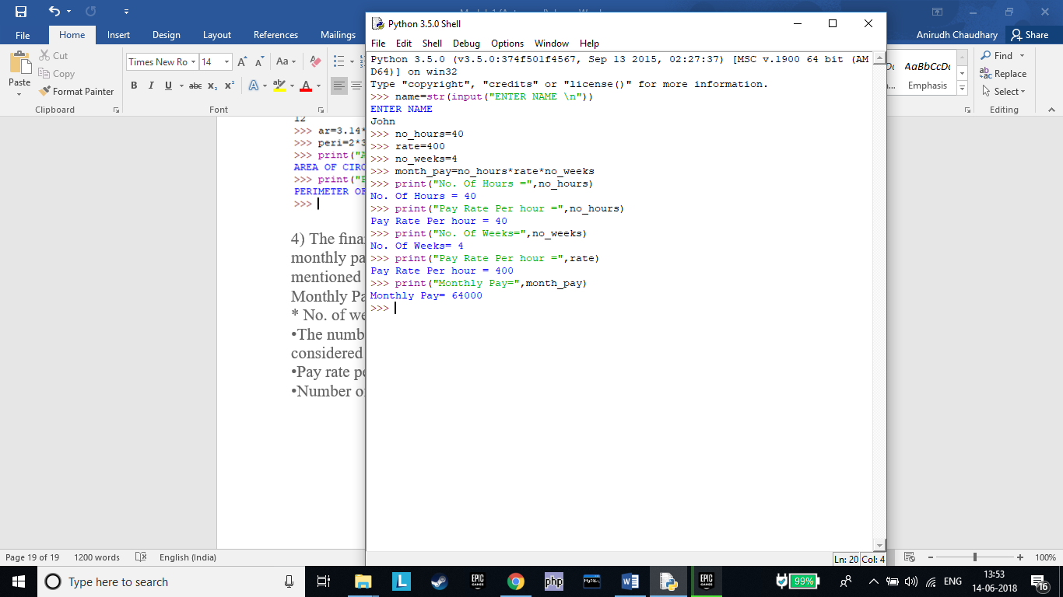

***Assignment 12***

Identify the sections of the given program where the coding standards are not followed and correct them.

•itemNo =1005

# item_no =1005

•unitprice = 250

#unit_price =250

•quantity = 2

#Correct

•amount=quantity*unitprice

#amount = quantity * unit_price

•print("Item No:", itemNo)

# print("Item No:", item_no)

•print("Bill Amount:", amount)

#Correct

***Assignment 13***

•Create a new ﬁle in Python IDLE as "triangle.py"

•Write a Python program to calculate and print the area of the triangle. Prompt the user to input the values for base and height of the triangle.

•Execute the program(use 'Run Module' under 'Run' tab) and observe the output.

•Close the ﬁle, open it again and execute it once more with diﬀerent values. Observe the output.

Hint – Use type casting for converting the input into an integer.

Area of a triangle = ½ * base * height

#

base=int(input("ENTER BASE "))

height=int(input("ENTER HEIGHT "))

ar=.5*base*height

print("THE AREA OF TRAINGLE IS",ar)

#

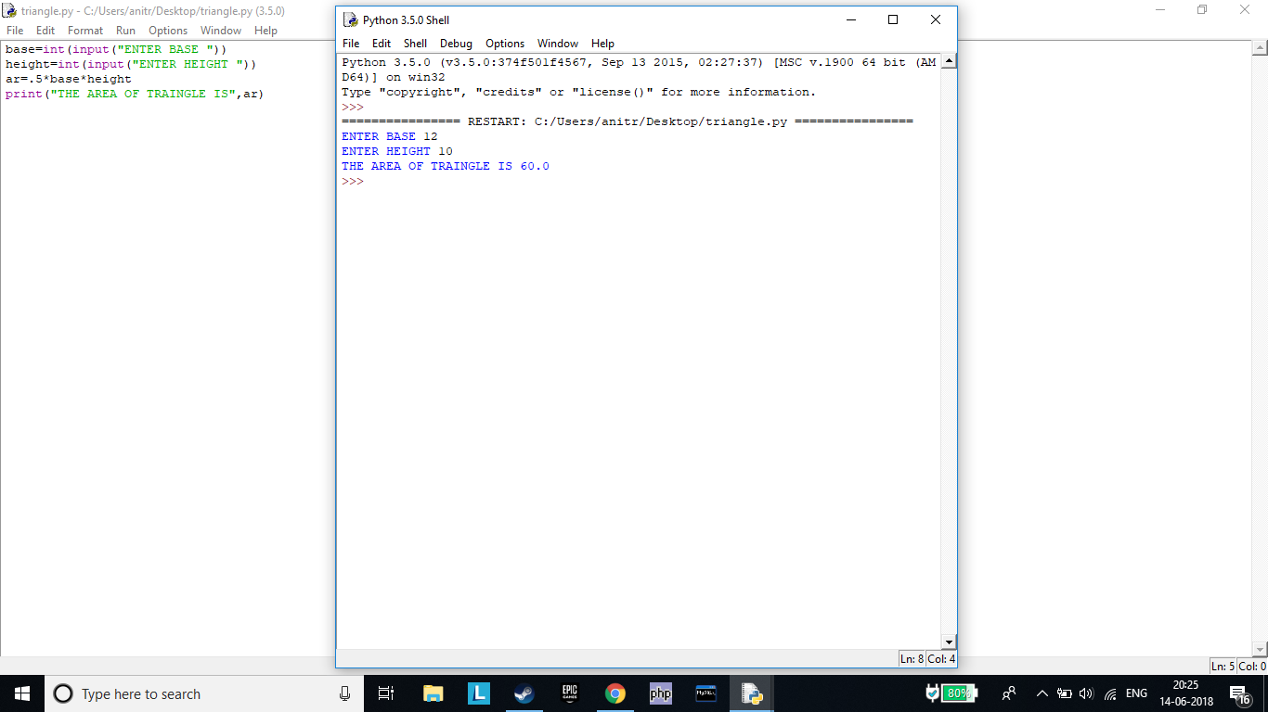

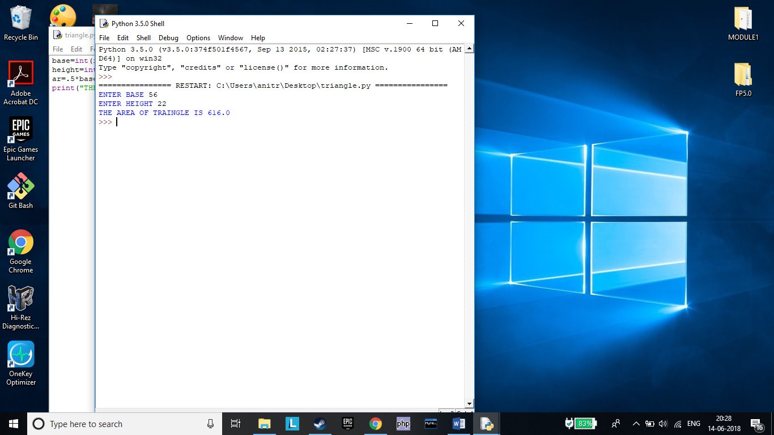

***Assignment 14***

1)Consider the scenario of retail store management again. The store provides discount for all bill amounts based on the criteria below:

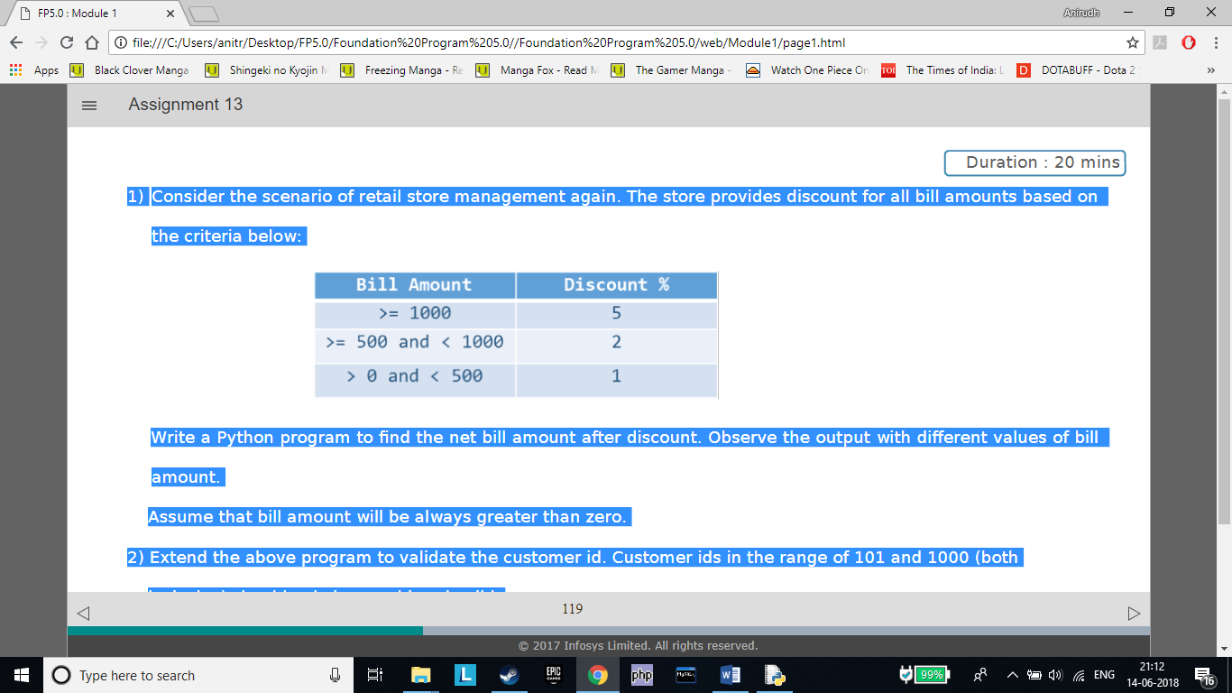

Write a Python program to ﬁnd the net bill amount after discount. Observe the output with diﬀerent values of bill amount.

Assume that bill amount will be always greater than zero.

#

bill=int(input("ENTER BILL AMOUNT\n"))

if(bill>=1000):

net=bill-(.05*bill)

elif(bill>=500) & (bill<1000):

net=bill-(.02*bill)

else:

net=bill-(.01*bill)

print("NET BILL IS ",net)

#

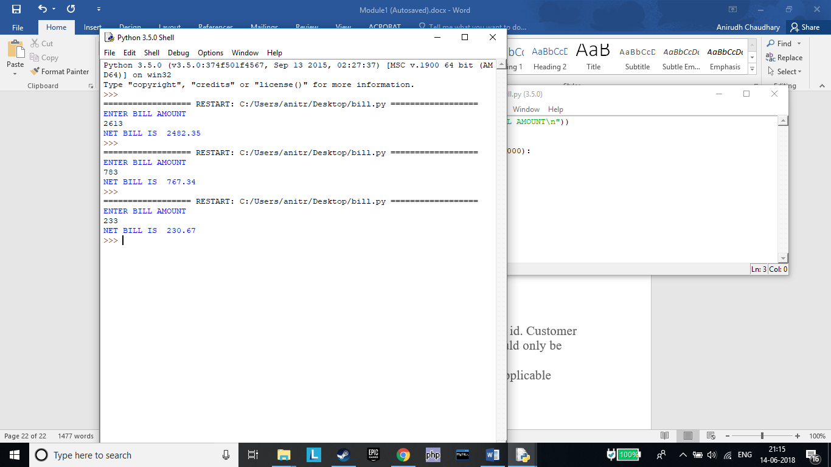

2) Extend the above program to validate the customer id. Customer ids in the range of 101 and 1000 (both inclusive) should only be considered valid.

Note: Display appropriate error messages wherever applicable

#

bill=int(input("ENTER BILL AMOUNT\n"))

cust_id=int(input("ENTER CUSTOMER ID\n"))

if(cust_id>=101)&(cust_id<=1000):

if(bill>=1000):

net=bill-(.05*bill)

elif(bill>=500) & (bill<1000):

net=bill-(.02*bill)

else:

net=bill-(.01*bill)

print("NET BILL IS ",net)

else:

print("DISCOUNT NO AVAILABLE ")

#

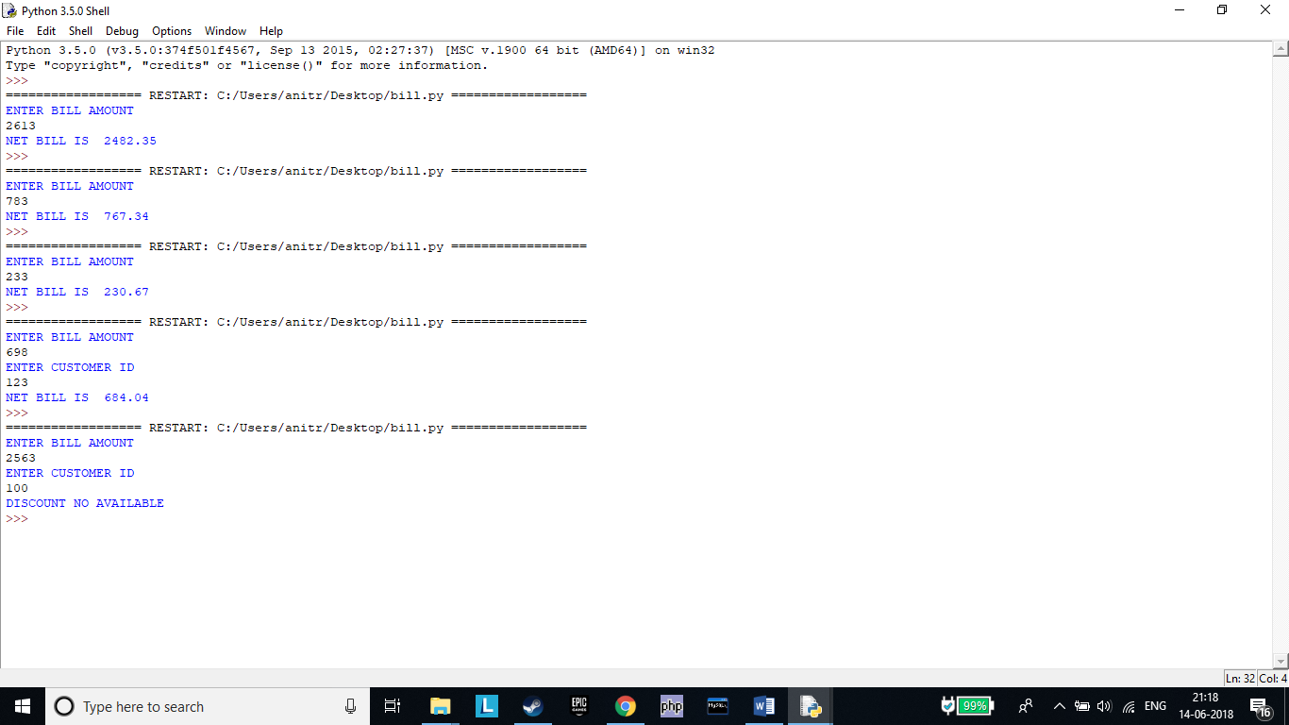

***Assignment 15***

Implement the following in Python:

a. Display all even numbers between 50 and 80 (both inclusive) using "for" loop.

#

num=0

for num in range(50,82,2):

print(num)

#

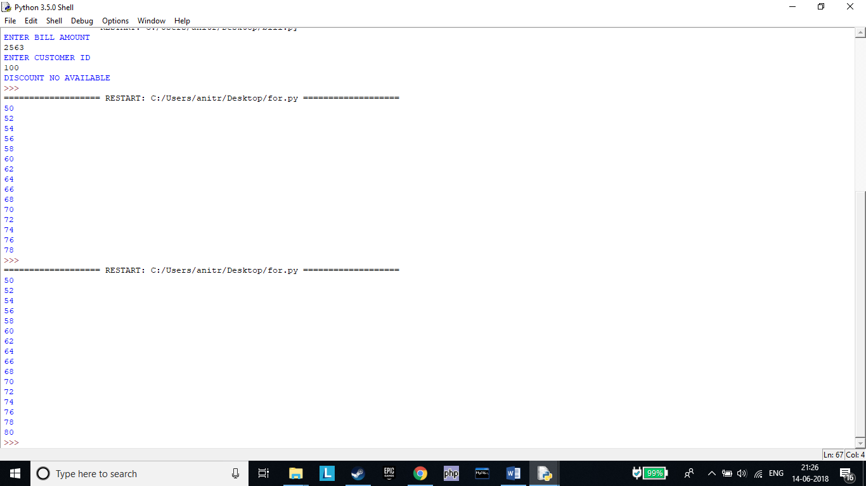

b. Add natural numbers up to n where n is taken as an input from user. Print the sum.

#

num=int(input("ENTER NUMBER\n"))

x=0

sum=0

while x<=num:

sum+=x

x+=1

print("SUM IS ",sum)

#

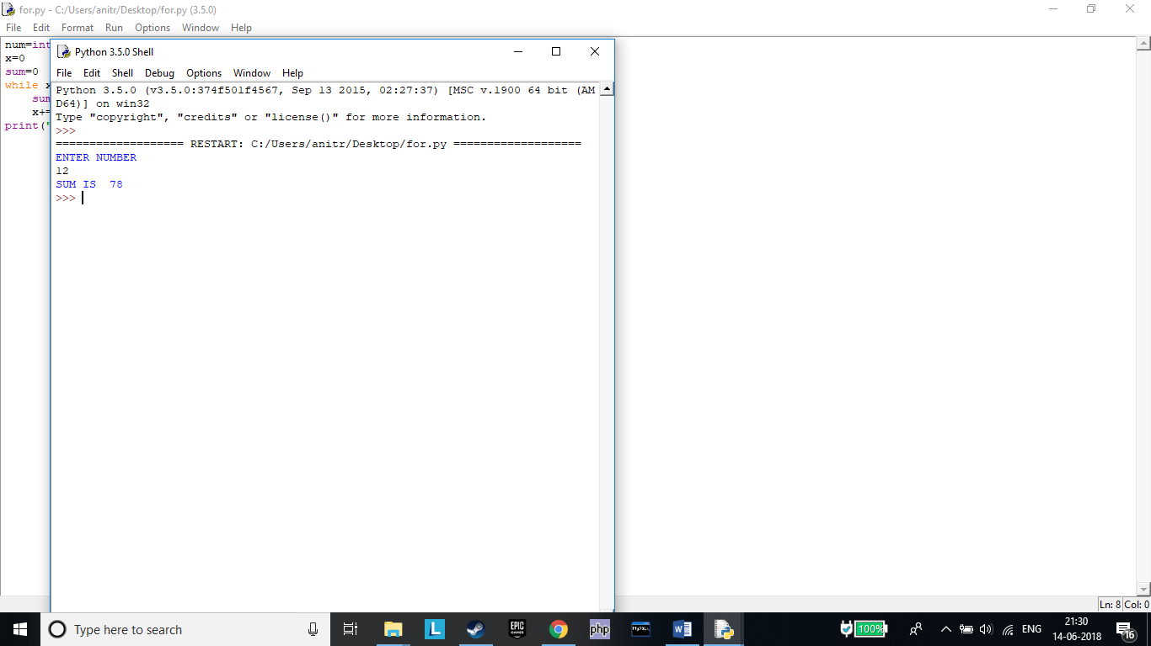

c. Prompt the user to enter a number. Print whether the number is prime or not.

#

num=int(input("ENTER NUMBER "))

if num > 1:

for i in range(2,num):

if (num % i) == 0:

print(num,"is not a prime number")

break

else:

print(num,"is a prime number")

else:

print(num,"is not a prime number")

#

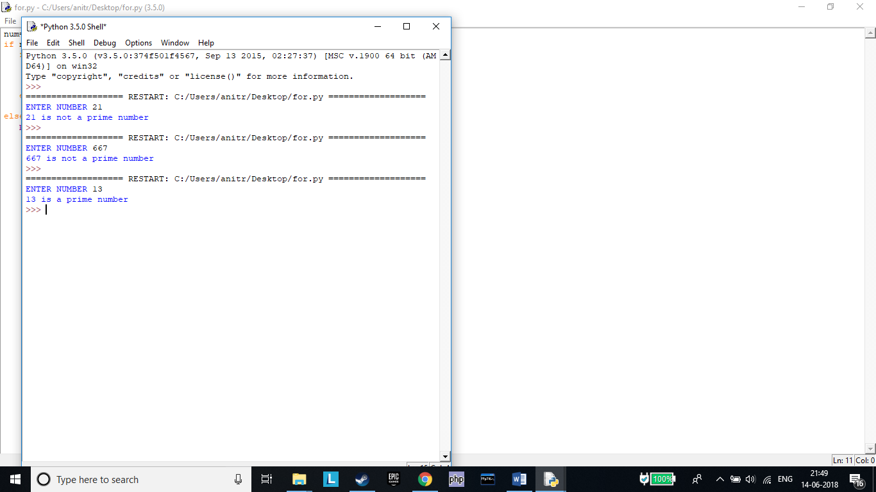

d. Print Fibonacci series till nth term where n is taken as an input from user.

Hint – Fibonacci series is a series of numbers in which each number is the sum of the two preceding numbers.

#

n=int(input("ENTER VALUE OF N "))

t1,t2=0,1

print(t2)

for i in range(1,n):

t3=t1+t2

t1=t2

t2=t3

print(t3)

#

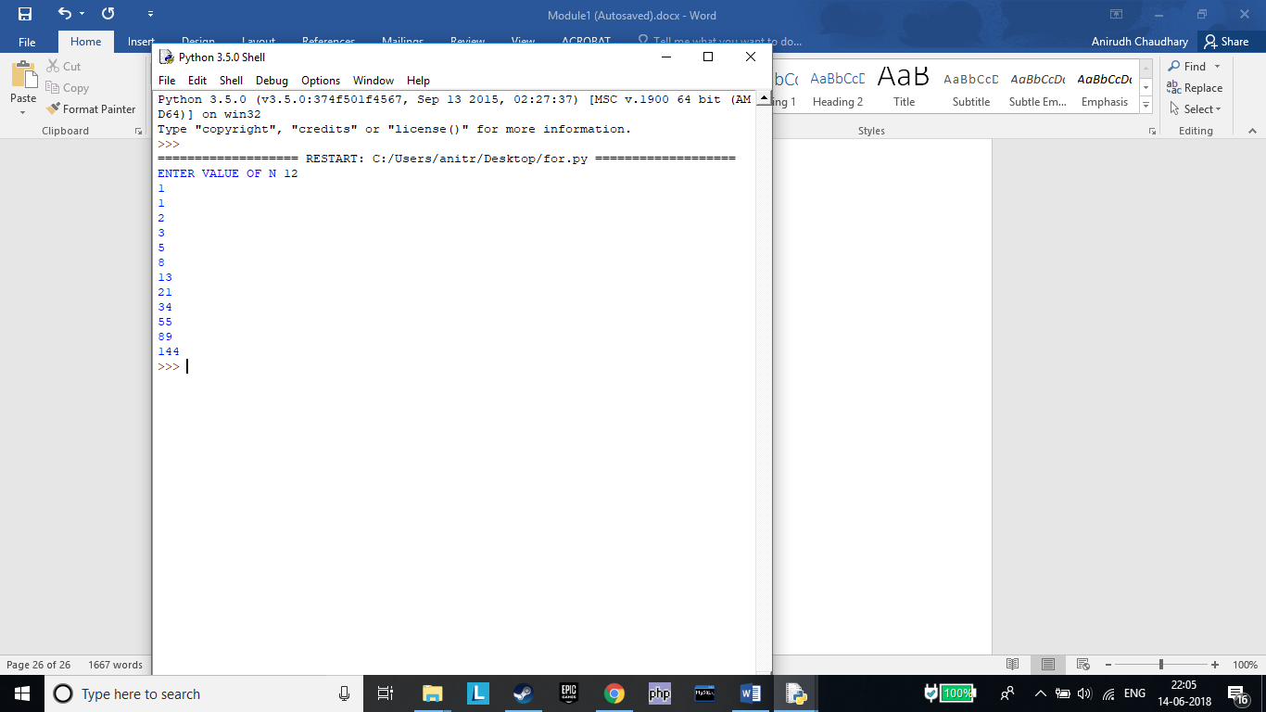

***Assignment 16***

Create four string variables a, b, c, d to store the following values and display them:

•My city is Mexico

•Raghu is my friend's brother

•My favorite programming language is "Python"

•Python is a widely used high-level, general-purpose, interpreted, dynamic programming language. It's design philosophy emphasizes code readability, and it's syntax allows programmers to express concepts in fewer lines of code than possible in languages such as "C++" or "Java".

#

a="My city is Mexico"

b="Raghu is my friend's brother"

c='My favorite programming language is "Python"'

d="""Python is a widely used high-level, general-purpose, interpreted, dynamic programming language. It's design philosophy emphasizes code readability, and it's syntax allows programmers to express concepts in fewer lines of code than possible in languages such as "C++" or "Java"."""

print(a)

print(b)

print(c)

print(d)

#

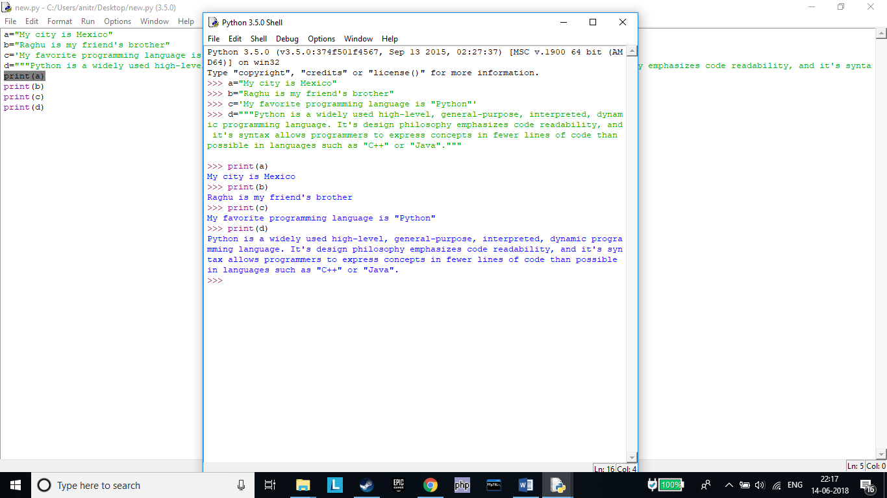

***Assignment 17***

•Accept a string as an input from the user. Check if the accepted string is palindrome or not.

•If the string is palindrome, print "String is palindrome", otherwise print "String is not palindrome".

•Also print the actual and the reversed strings.

Note – Ignore the case of characters.

Hint – A palindrome string remains the same if the characters of the string are reversed

#

ch=str(input("ENTER STRING\n"))

print("ACTUAL STRING",ch[0:])

print("REVERSED STRING",ch[::-1])

if(ch[:]==ch[::-1]):

print("STRING IS PALINDROME")

else:

print("STRING IS NOT PALINDROME")

#

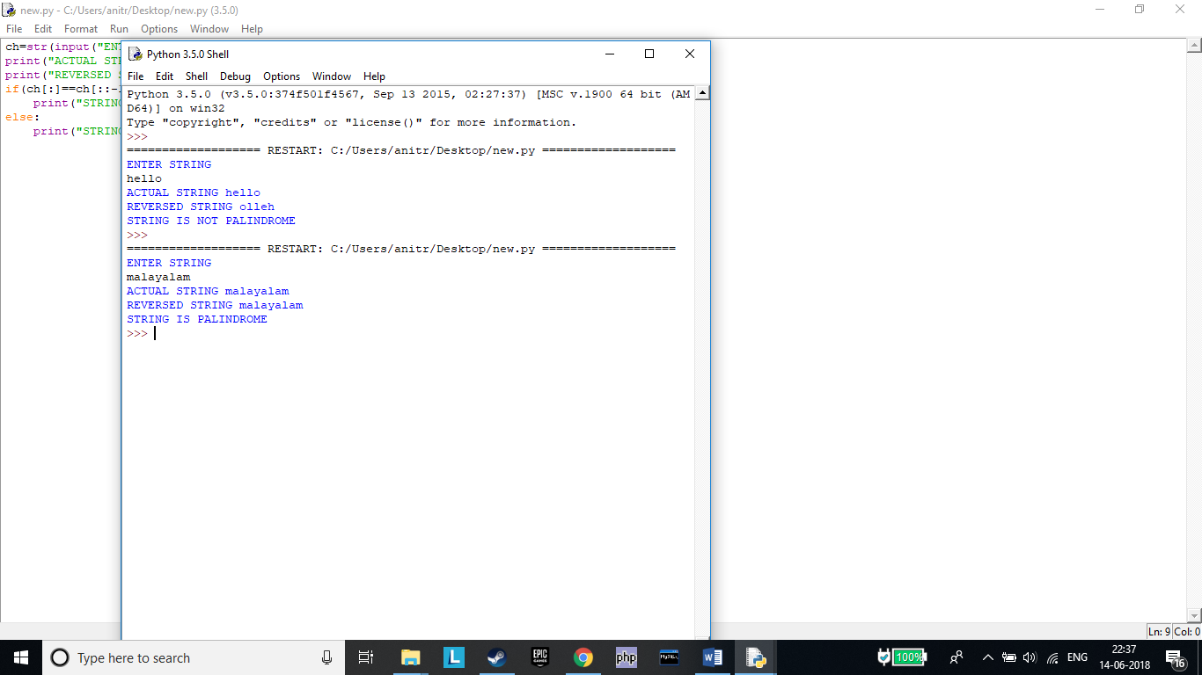

***Assignment 18***

Accept two strings 'string1' and 'string2' as an input from the user. Generate a resultant string, such that it is a concatenated string of all upper case alphabets from both the strings in the order they appear. Print the actual and the resultant strings.

Note: Each character should be checked if it is a upper case alphabet and then it should be concatenated to the resultant string.

Sample Input:

string1: I Like C

string2: Mary Likes Python

Output: ILCMLP

#

string1=str(input("ENTER STRING 1 \n"))

string2=str(input("ENTER STRING 2 \n"))

ch=string1+string2

print("ACTUAL STRING:",ch)

k=''

for i in ch:

if(i.isupper()):

k+=i

print("RESULTANT STRING:",k)

#

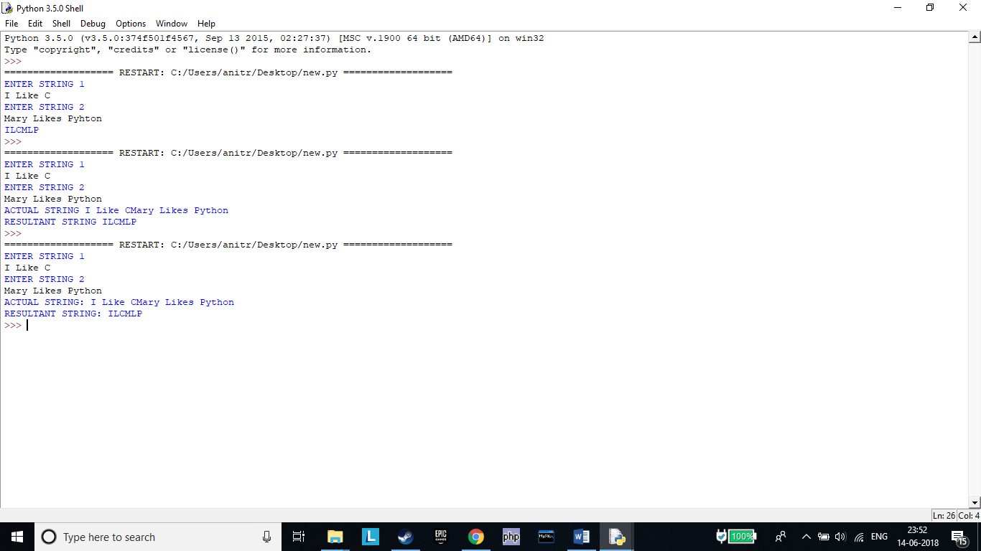

***Assignment 19***

Given a string containing both upper and lower case alphabets. Write a Python program to count the number of

occurrences of each alphabet(case insensitive) and display the same.

Sample Input: ABaBCbGc

Sample Output:

2A

3B

2C

1G

#

ch=str(input("ENTER STRING \n"))

print("ACTUAL STRING:",ch)

count=0

k={}

for i in ch:

if(i!=' '):

k[i]=ch.count(i)

for d in k:

print(k[d],d)

#

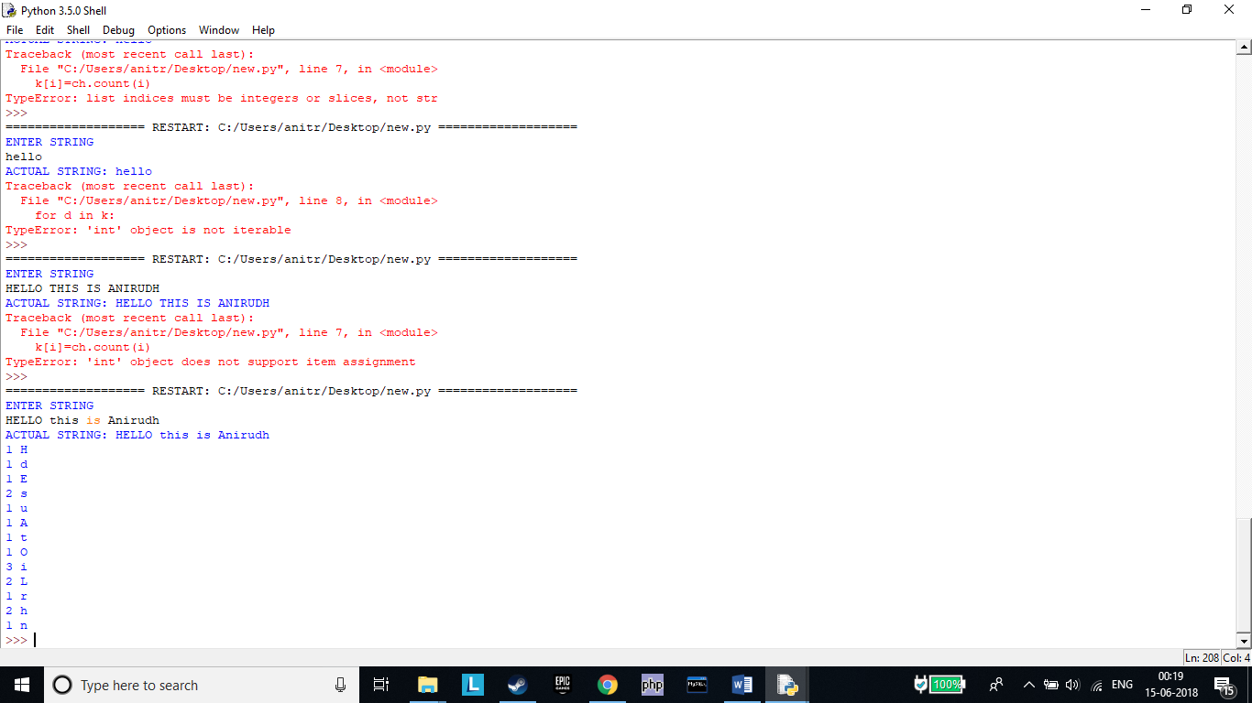

***Assignment 20***

Write a Python program to accept a string 'accepted_string'. Generate a resultant string 'resultant_string' such that 'resultant_string' should contain all characters at the even position of 'accepted_string' (ignoring blank spaces). Display 'resultant_string' in reverse order.

accepted_string: An apple a day keeps the doctor away

resultant_string: Aapedyepteotrwy

expected_output: ywrtoetpeydepaA

Hint: String starts from index 0, hence the starting character is at even position.

#

accepted_str=str(input("ENTER STRING \n"))

print("ACTUAL STRING:",accepted_str)

accepted_str=accepted_str.replace(' ','')

resultant_str=accepted_str[::2]

print("RESULTANT STRING:",resultant_str)

print("REVERSED STRING:",resultant_str[::-1])

#

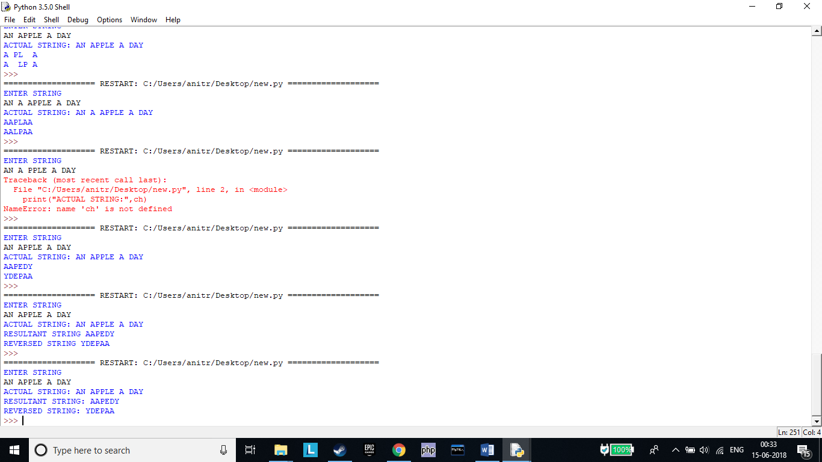

***Assignment 21***

Write a Python program to generate ﬁrst 'n' Fibonacci numbers where 'n' is accepted as an input from the user.

Store the generated Fibonacci numbers in a list and display the output.

Sample input: 5

Sample output: [0, 1, 1, 2, 3]

#

n=int(input("ENTER VALUE OF N "))

t= [0, 1]

for i in range(2,n):

t.append(t[i-1]+t[i-2])

print(t)

#

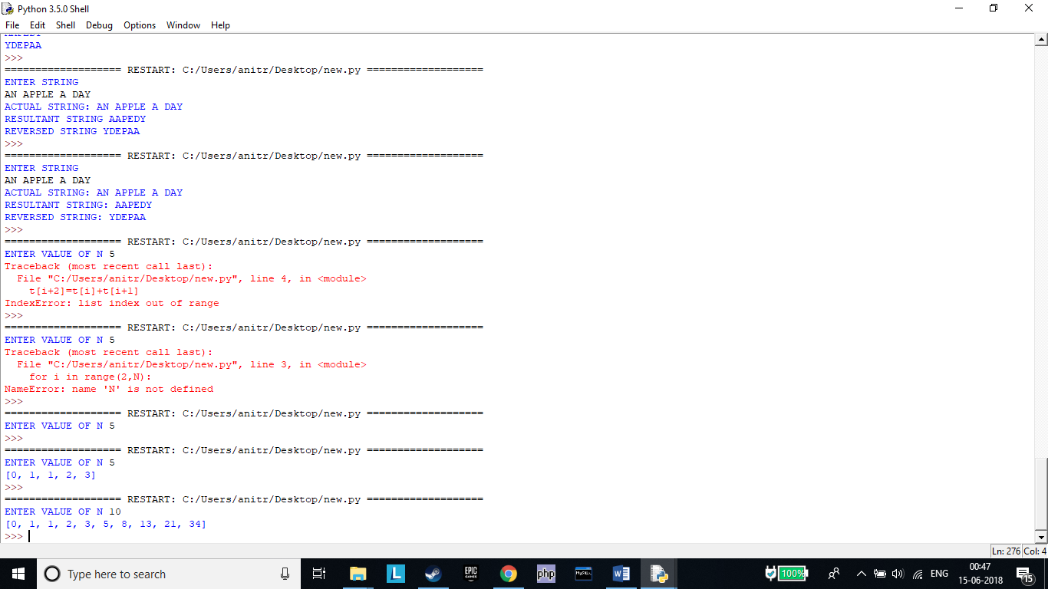

***Assignment 22***

The "Variety Retail Store" sells diﬀerent varieties of Furniture to the customers. The list of furniture available with its respective cost is given below:

The furniture and its corresponding cost should be stored as a list. A customer can order any furniture in any quantity (the name and quantity of the furniture will be provided). If the required furniture is available in the furniture list(given above) and quantity to be purchased is greater than zero, then bill amount should be calculated.

In case of invalid values for furniture required by the customer and quantity to be purchased, display appropriate error message and consider bill amount to be 0. Initialize required furniture and quantity with diﬀerent values and test the results.

Write a Python program to calculate and display the bill amount to be paid by the customer based on the furniture bought and quantity purchased.

#

furni=['Sofa Set','Dining Table','T.V. Stand','Cupboard']

cost=[20000,8500,4599,13920]

item=input("ENTER FURNITURE\n")

qty=int(input("ENTER QUANTITY\n"))

if(qty>0) & (item in furni):

for i in range(0,len(furni)):

if(item==furni[i]):

print(furni[i])

print("TOTAL COST IS ",qty*cost[i])

else:

print("ENTER VALID INPUT")

#

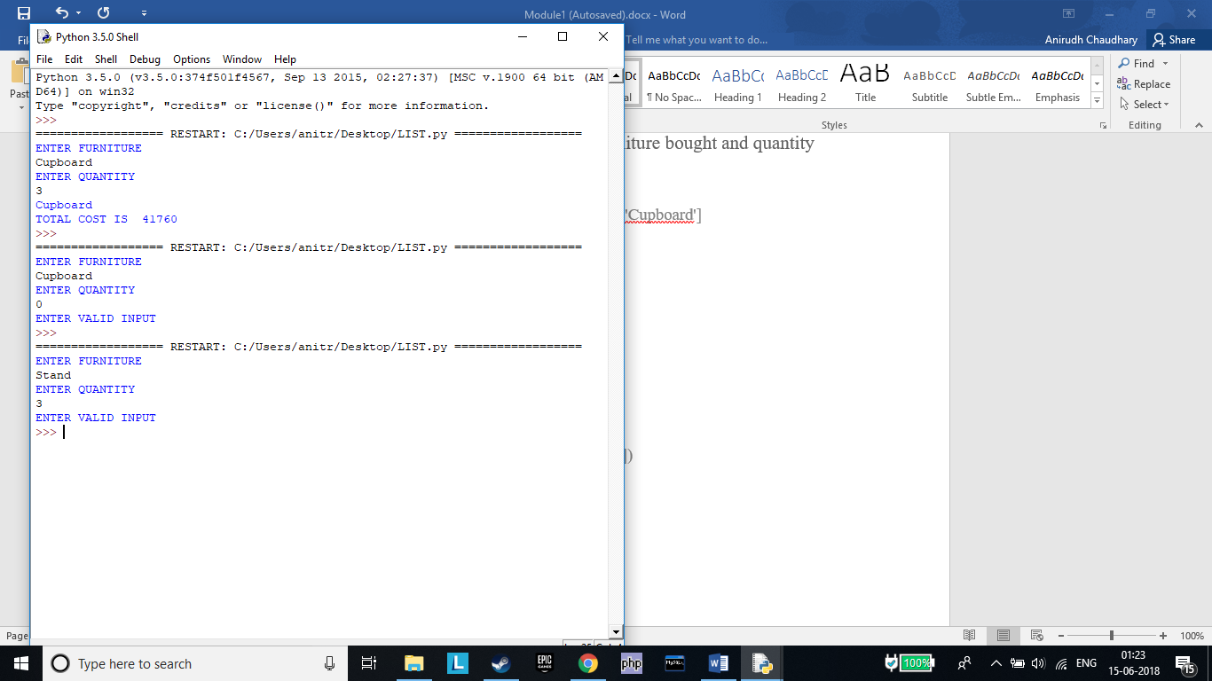***Assignment 23***

Consider the list of courses opted by a Student "John" and available electives at ABC Training Institute:

courses = ("Python Programming", "RDBMS", "Web Technology", "Software Engg.")

electives = ("Business Intelligence", "Big Data Analytics")

Write a Python Program to satisfy business requirements mentioned below:

1.List the number of courses opted by John.

2.List all the courses opted by John.

3.John is also interested in elective courses mentioned above. Print the updated tuple including electives.

#

courses = ("Python Programming", "RDBMS", "Web Technology", "Software Engg.")

electives = ("Business Intelligence", "Big Data Analytics")

print("NUMBER OF COURSES OPTED ARE ",len(courses))

print("ALL OPTED COURSES ARE ",courses)

all_course=courses+electives

print("OPTED COURSES PLUS ELECTIVES ",all_course)

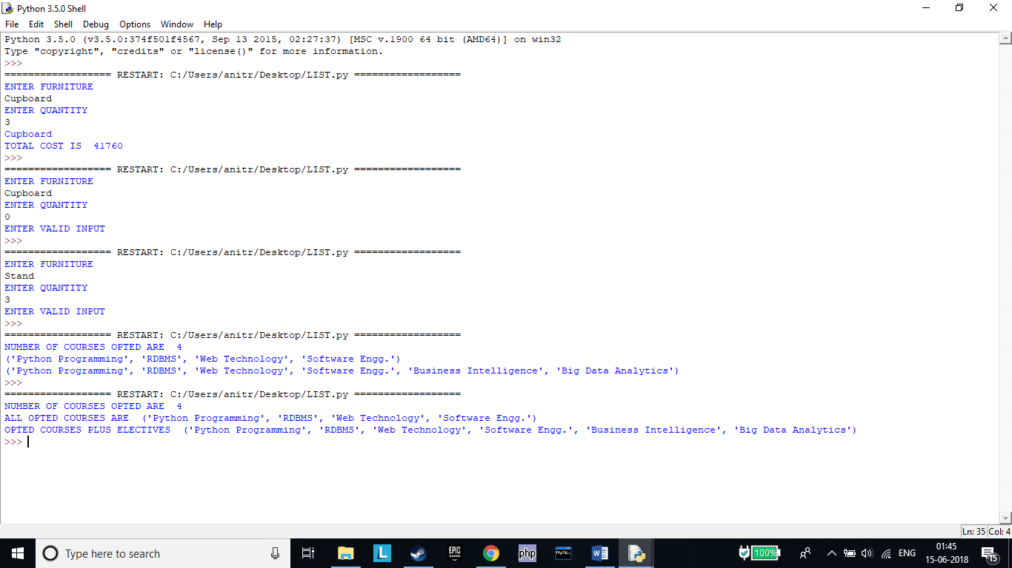

***Assignment 24***

Given below is a dictionary 'customer_details' representing customer details from a Retail Application. Customer Id is the key and Customer Name is the value.

customer_details = { 1001 : "John", 1004 : "Jill", 1005: "Joe", 1003 : "Jack" }

Write Python code to perform the operations mentioned below:

a)Print details of customers.

b)Print number of customers.

c)Print customer names in ascending order.

d)Delete the details of customer with customer id = 1005 and print updated dictionary.

e)Update the name of customer with customer id = 1003 to "Mary" and print updated dictionary.

f)Check whether details of customer with customer id = 1002 exists in the dictionary.

#

customer_details = { 1001 : "John", 1004 : "Jill", 1005: "Joe", 1003 : "Jack" }

print(customer_details)

print(len(customer_details))

for i in sorted(customer_details):

print(customer_details[i])

del customer_details[1005]

print(customer_details)

d={1003 : "Mary"}

customer_details.update(d)

print(customer_details)

key=1002

print(key)

if key in customer_details:

print("Key is present and value of the key is:")

print(key)

else:

print("Key isn't present!")

#

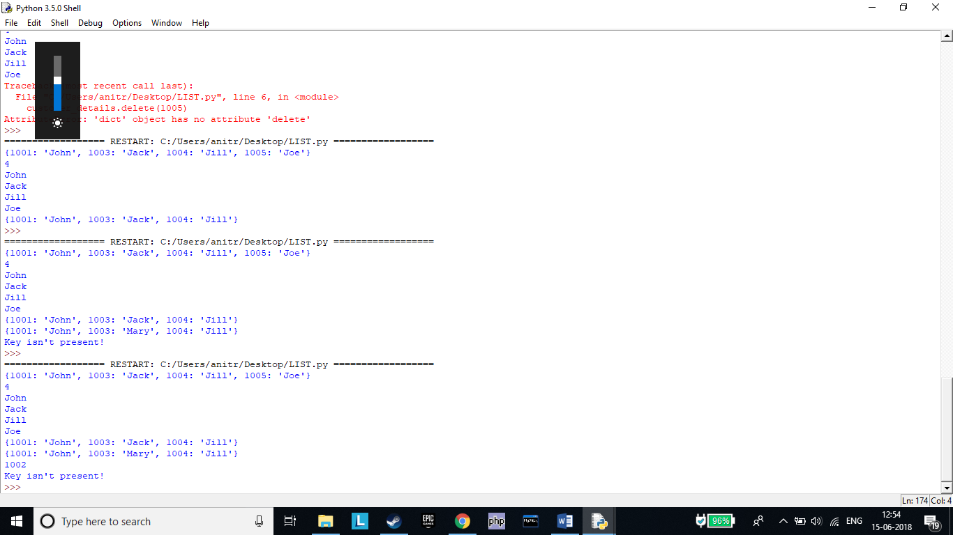

***Assignment 25***

Consider a scenario from ABC Training Institute. The given table shows the marks scored by students of grade XI in

Python Programming course.

Write a Python program to meet the requirements mentioned below:

a. Display the name and marks for every student.

b. Display the top two scorers for the course.

c. Display class average of this course.

Hint- Implement the solution using a dictionary.

#

details= { "John" : 86.5, "Jill" : 84.5, "Joe" : 80.5, "Jack" : 91.2 , "Harry" : 72.1}

print(details)

print(max(details, key=details.get))

sm=0

for i,j in details.items():

sm+=j

avg=sm/len(details)

print(avg)

#

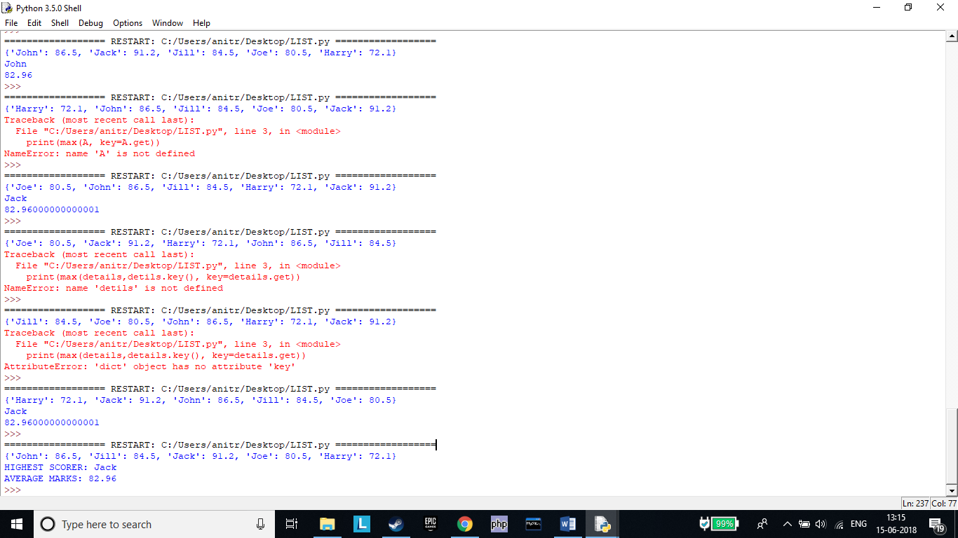

***Assignment 26***

Consider the scenario from "Variety Retail Store" discussed in 'List' section. The list of furniture available with its respective cost is given below:

A customer can order any furniture in any quantity. If the required furniture is available in the furniture list(given above) and quantity to be purchased is greater than zero, then bill amount should be calculated. In case of invalid values for furniture required by the customer and quantity to be purchased, display appropriate error message and consider bill amount to be 0. Initialize required furniture and quantity with diﬀerent values and test the results.

Calculate and display the bill amount to be paid by the customer based on the furniture bought and quantity purchased. Implement the given scenario using:

1)List of tuples

#

lis=[('Sofa Set',20000),('Dining Table',8500),('T.V. Stand',4599),('Cupboard',13920)]

print(lis)

item=input("ENTER FURNITURE\n")

qty=int(input("ENTER QUANTITY\n"))

if(qty>0):

for i in range(0,len(lis)):

if(item in lis[i]):

print(lis[i])

print("TOTAL COST IS ",qty*lis[i])

else:

print("ENTER VALID INPUT")

#

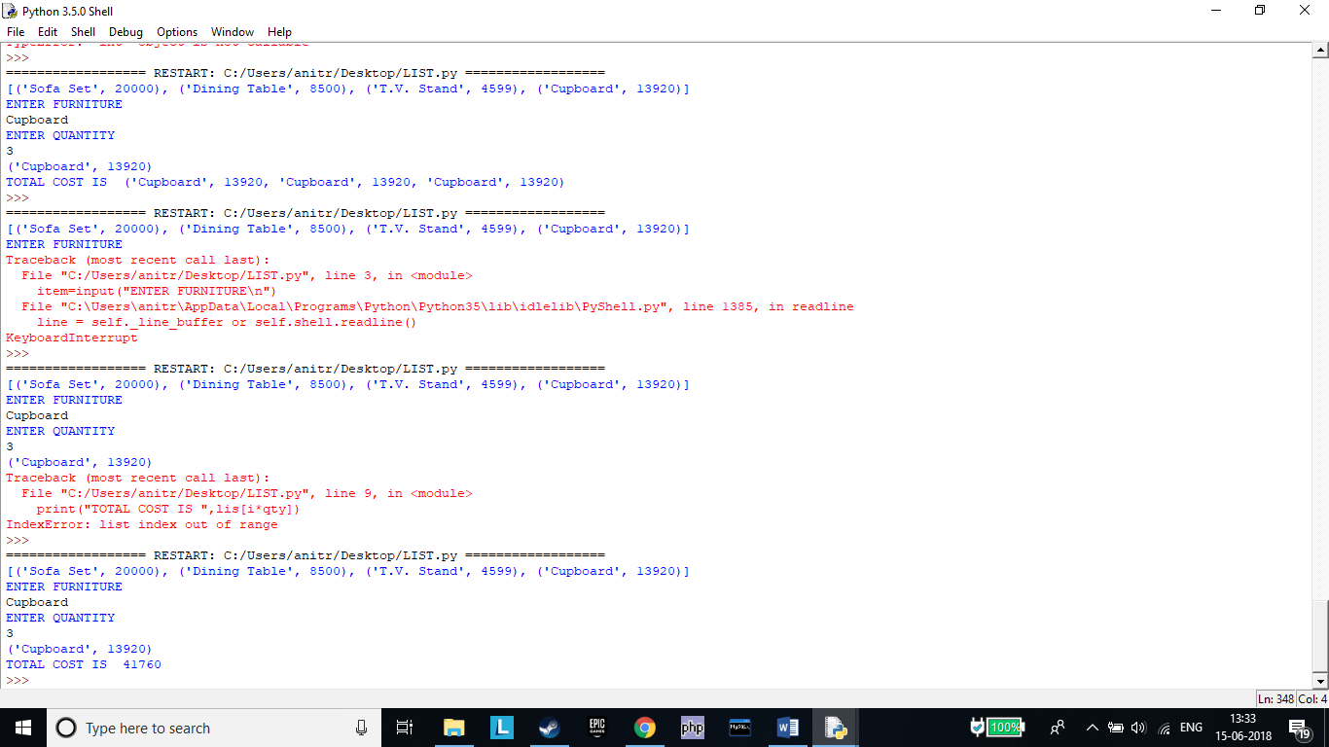

2)Dictionary

#

lis={'Sofa Set':20000,'Dining Table':8500,'T.V. Stand':4599,'Cupboard':13920}

print(lis)

item=input("ENTER FURNITURE\n")

qty=int(input("ENTER QUANTITY\n"))

if(qty>0):

for i,j in lis.items():

if(item==i):

print(i)

print("TOTAL COST IS ",qty*j)

else:

print("ENTER VALID INPUT")

#

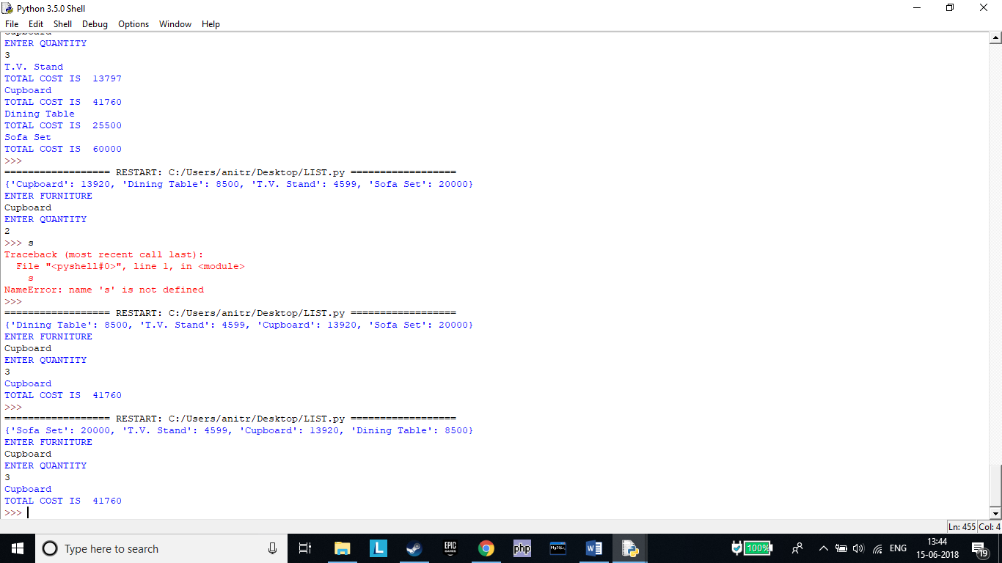

***Assignment 27***

Consider a scenario from ABC Training Institute. Given below are two Sets representing the names of students enrolled for a particular course:

java_course = {"John", "Jack", "Jill", "Joe"}

python_course = {"Jake", "John", "Eric", "Jill"}

Write a Python program to list the number of students enrolled for:

1)Python course

2)Java course only

3)Python course only

4)Both Java and Python courses

5)Either Java or Python courses but not both

6)Either Java or Python courses

#

java_course = {"John", "Jack", "Jill", "Joe"}

python_course = {"Jake", "John", "Eric", "Jill"}

print("STUDENTS IN JAVA:",java_course)

print("STUDENTS IN PYTHON:",python_course)

print("STUDENTS IN JAVA ONLY:",java_course - python_course)

print("STUDENTS IN PYTHON ONLY:",python_course - java_course)

print("STUDENTS IN PYTHON & JAVA:",python_course & java_course)

print("STUDENTS IN PYHTON OR JAVA BUT NOT BOTH:",python_course ^ java_course)

print("STUDENTS IN PYTHON OR JAVA:",python_course | java_course)

#

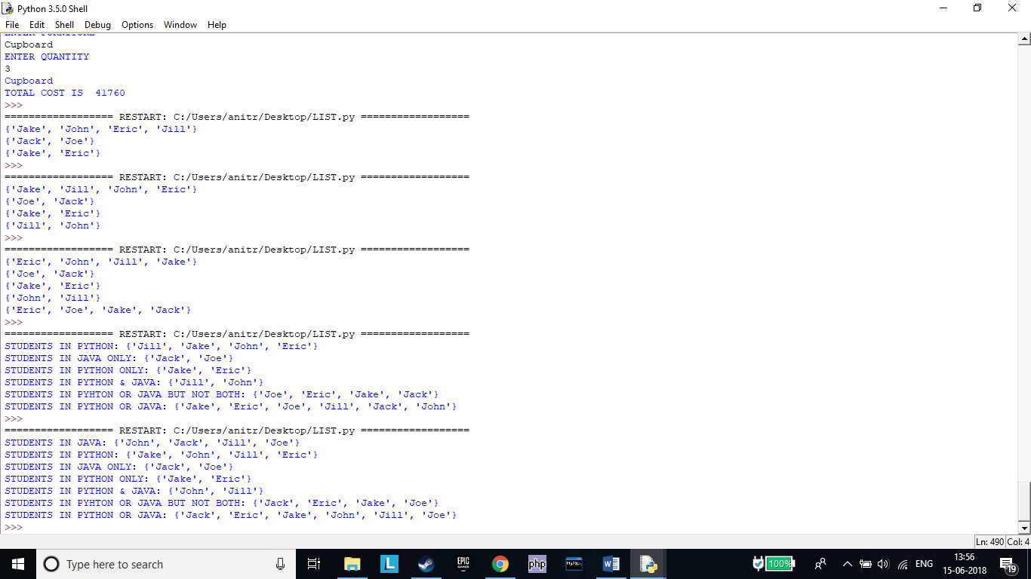

***Assignment 28***

Using functions, re-write and execute Python program to:

1.Add natural numbers upto n where n is taken as an input from user.

#

num=int(input("ENTER NUMBER\n"))

def total(num):

x=sum=0

while x<=num:

sum+=x

x+=1

print("SUM IS ",sum)

total(num)

#

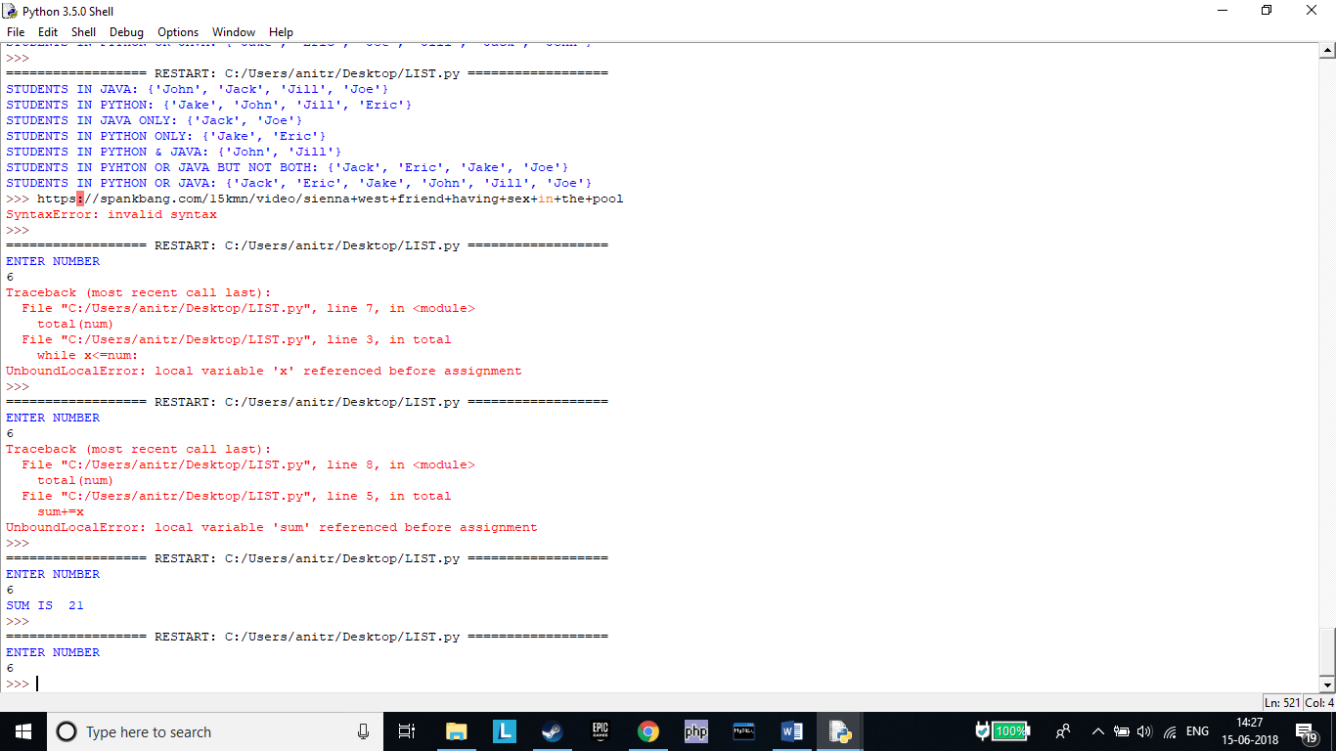

2.Print Fibonacci series till nth term (Take input from user).

Note: You have implemented these programs using loops earlier.

#

n=int(input("ENTER VALUE OF N "))

def fibo(num):

t1,t2=0,1

print(t2)

for i in range(1,n):

t3=t1+t2

t1=t2

t2=t3

print(t3)

fibo(n)

#

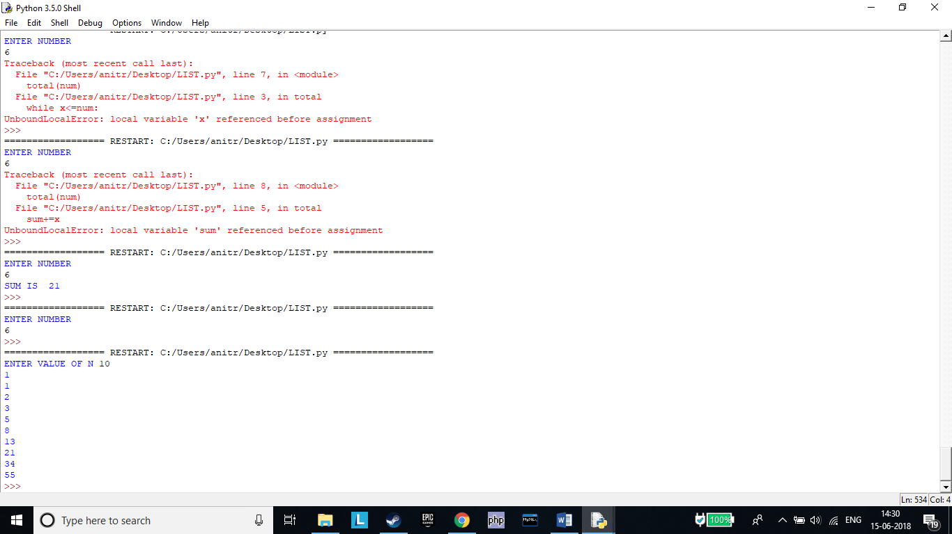

***Assignment 29***

At an airport, a traveler is allowed entry into the ﬂight only if he clears the following checks:

1.Baggage Check

2.Immigration Check

3.Security Check

The logic for the check methods are given below:

check_baggage (baggage_weight)

•returns True if baggage_weight is greater than or equal to 0 and less than or equal to 40. Otherwise returns False.

check_immigration (expiry_year)

•returns True if expiry_year is greater than or equal to 2001 and less than or equal to 2025. Otherwise returns False.

check_security(noc_status)

•returns True if noc_status is 'valid' or 'VALID', for all other values return False.

traveler()

•Initialize the traveler Id and traveler name and invoke the functions check_baggage(), check_immigration() and check_security() by passing required arguments.

•Refer the table below for values of arguments.

•If all values of check_baggage(), check_immigration() and check_security() are true,

display traveler_id and traveler_name

display "Allow Traveler to ﬂy!" Otherwise,

display traveler_id and traveler_name

display "Detain Traveler for Re-checking!“

Invoke the traveler() function. Modify the values of diﬀerent variables in traveler() function and observe the output.

#

def check_baggage (baggage_weight):

if (baggage_weight>=0) & (baggage_weight<=40):

return True

else:

return False

def check_immigration(expiry_year):

if (expiry_year>=2001) & (expiry_year<=2025):

return True

else:

return False

def check_security(noc_status):

if (noc_status=='valid') | (noc_status=='VALID'):

return True

else:

return False

def traveler():

traveler_id=int(input("ENTER TRAVELER ID \n"))

traveler_name=input("ENTER TRAVELER NAME \n")

baggage_weight=int(input("ENETR BAG WEIGHT\n"))

expiry_year=int(input("ENETR TRAVEL YEAR\n"))

noc_status=input("ENETR NOC STATUS(VALID)\n")

if(check_baggage (baggage_weight) is True)&(check_immigration(expiry_year) is True)&(check_security(noc_status) is True):

print("CUSTOMER ID: ",traveler_id)

print("CUSTOMER NAME: ",traveler_name)

print("ALLOW TO FLY")

else:

print("CUSTOMER ID: ",traveler_id)

print("CUSTOMER NAME: ",traveler_name)

print("DETAIN TRAVELER FOR RE-CHECK")

traveler()

#

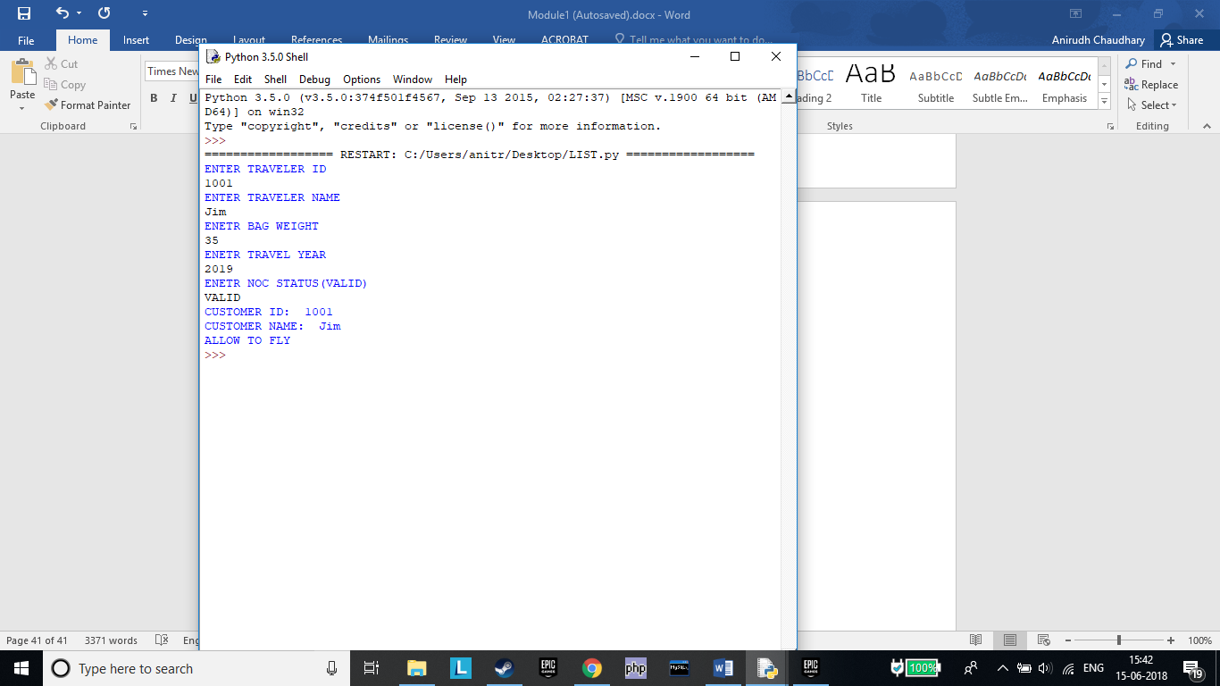

***Assignment 30***

Consider the pseudo code for generating Fibonacci series using Recursion:

FIBO (number) 1.

if (number = 0) then

2. return (0)

3. else if (number = 1) then

4. return (1)

5. else

6. return FIBO(number - 1) + FIBO(number - 2)

7. end if

Write a program in Python to implement the same using Recursion and execute it in Eclipse. Print appropriate error message if the user enters negative number as input.

#

def **fibo**(number):

if(number == 0):

return (0)

elif(number == 1):

return (1)

else:

return fibo(number - 1) + fibo(number - 2)

num=int(input(*"ENTER NUMBER"*))

if num<0:

print(*"ENTER VALID INPUT"*)

else:

for i in range(num):

print(fibo(i))

#

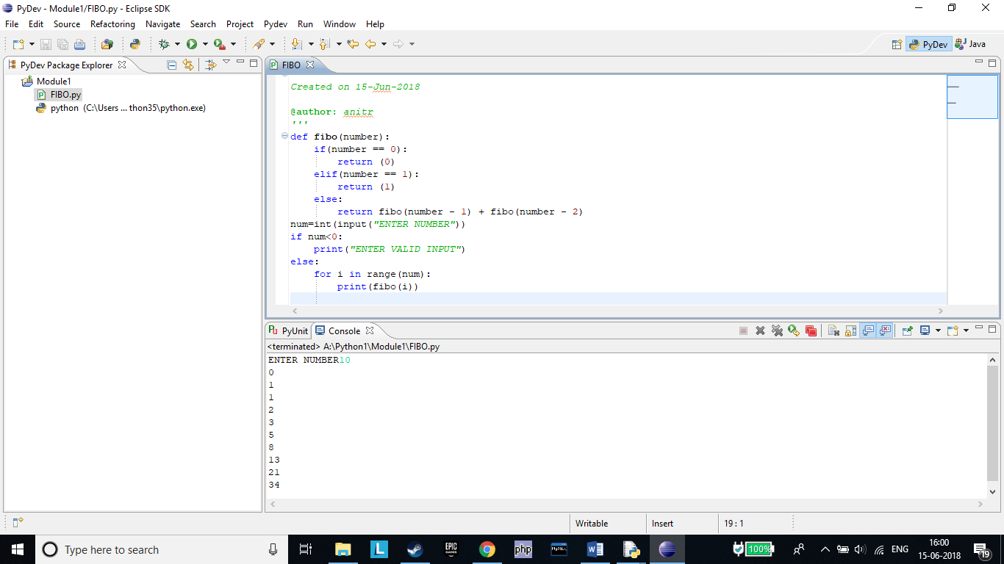

***Assignment 32***

Write a Python program to:

1.read a ﬁle.

2.add backslash (\) before every double quote in the ﬁle contents.

3.write it to another ﬁle in the same folder.

4.print the contents of both the ﬁles.

For example:

If the ﬁrst ﬁle is 'TestFile1.txt' with text as:

Jack said, "Hello Pune".

The output of the ﬁle 'TestFile2.txt' should be:

Jack said,\"Hello Pune\".

#

f=open(*"C:\\Users\\anitr\\Desktop\\testfile1.txt"*,*"r+"*)

data = f.read()

print(data)

f1=open(*"C:\\Users\\anitr\\Desktop\\testfile2.txt"*,*"w+"*)

f1.write(data.replace(*'\"'*, *'\\\"'*))

f1.close()

f.close()

f2=open(*"C:\\Users\\anitr\\Desktop\\testfile2.txt"*,*"r+"*)

data2=f2.read()

print(data2)

f2.close()

#

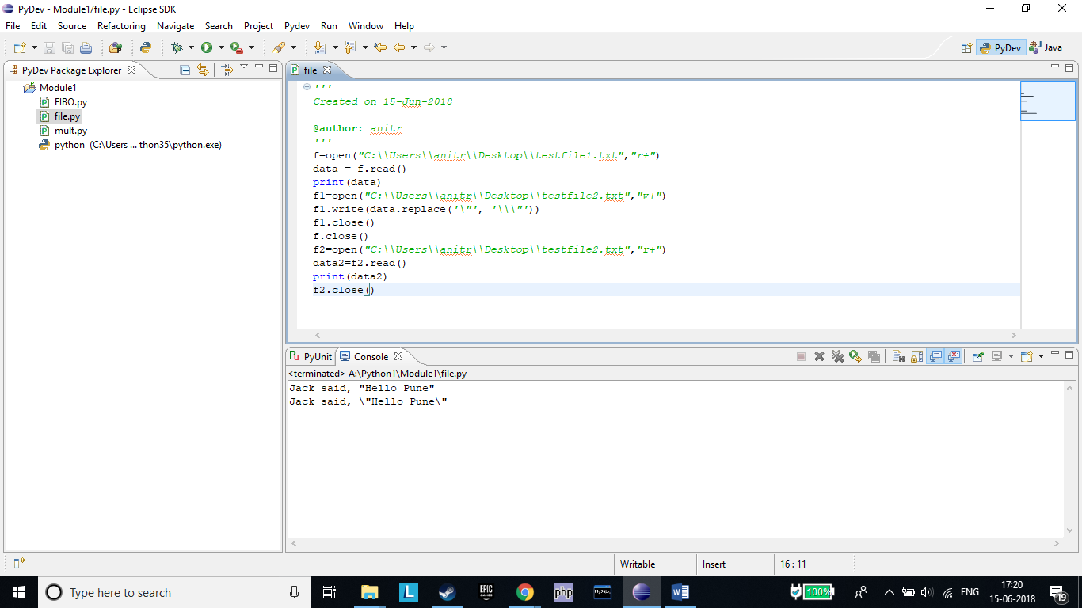

***Assignment 33***

Consider a ﬁle 'courses.txt' in D Drive with the following details:

Write a program to read the ﬁle and store the courses in Python variables as a:

1)Dictionary (Sample - {0: 'Java', 1: 'Python', 2:'Javascript' 3:'PHP'})

2)List ( Sample - ['Java', 'Python', 'Javascript', 'PHP'] )

#

lis=[]

dic={}

i=0

f=open(*"C:\\Users\\anitr\\Desktop\\course.txt"*,*"r+"*)

for line in f:

i+=1

lis.append(line)

dic[line]=i

print(lis)

print(dic)

f.close()

#

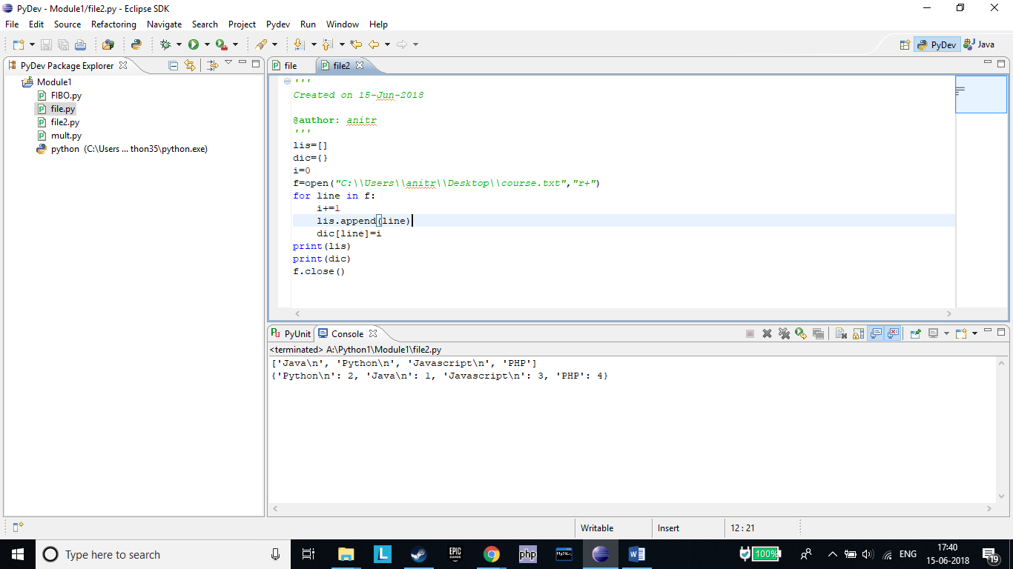

***Assignment 34***

Consider a ﬁle 'student_details.txt' in D Drive with the details of students in ABC institute – student id and name:

Write a program to read the ﬁle and store the student records in Python variable as:

1)List of lists

2)List of dictionaries

#lis=[]

lis2=[]

dic={}

i=0

f=open(*"C:\\Users\\anitr\\Desktop\\student_details.txt"*,*"r+"*)

for line in f:

temp=line.split()

i+=1

lis.append(temp)

dic[line]=i

print(lis)

lis2.append(dic)

print(lis2)

f.close()

#

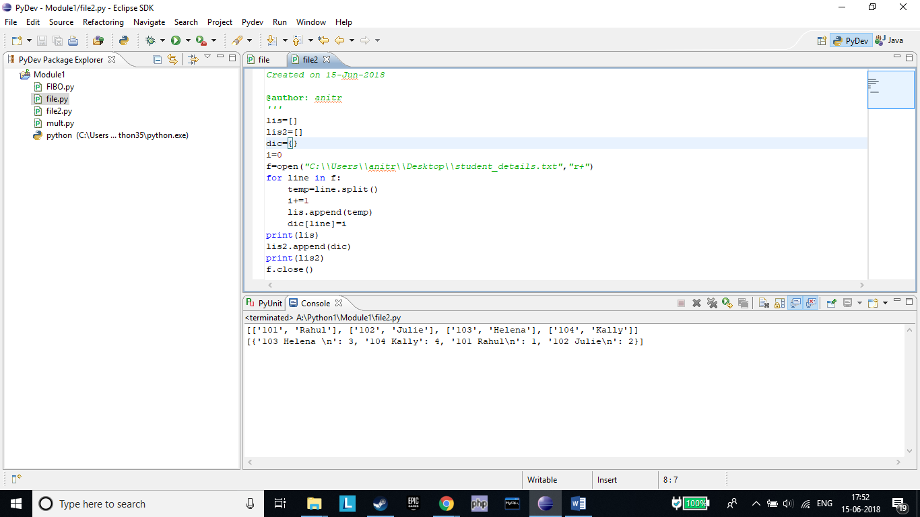

***Assignment 35***

Consider a ﬁle 'rhyme.txt' in D Drive with following text:

Write a Python program to count the words in the ﬁle using a dictionary (use space as a delimiter). Find unique words and the count of their occurrences(ignoring case). Write the output in another ﬁle "words.txt" at the same location

#

dic={}

dic2={}

i,count=0,0

f=open(*"C:\\Users\\anitr\\Desktop\\rhyme.txt"*,*"r+"*)

f1=open(*"C:\\Users\\anitr\\Desktop\\words.txt"*,*"w+"*)

for line in f:

for temp in line.split():

i+=1

dic[temp]=i

temp=temp.lower()

dic2[temp]=i

f1.write(*"TOTAL NO. OF WORDS: "*+str(i)+*"\n"*)

f1.write(str(dic)+*"\n"*)

f1.write(*"UNIQUE WORDS: "*+str(len(dic2))+*"\n"*)

for x in dic2:

f1.write(x+*"\n"*)

f.close()

f1.close()

f3=open(*"C:\\Users\\anitr\\Desktop\\words.txt"*,*"r+"*)

print(f3.read())

f3.close()

#

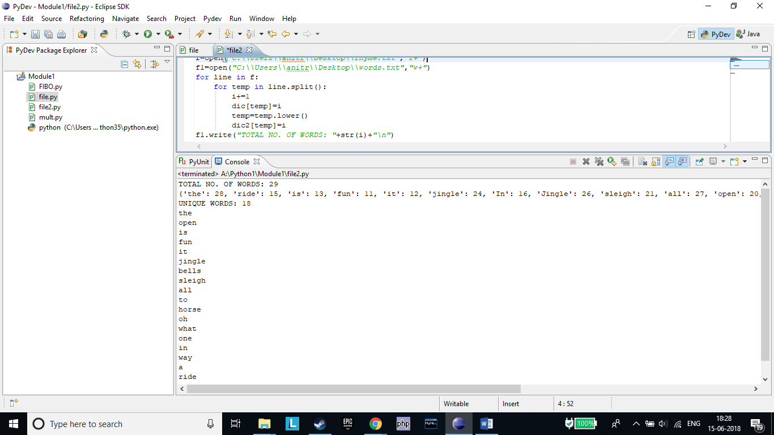

***Assignment 36***

Assume the following Python code:

mylist=[1,2,3,*"4"*,5]

sum=0

for i in mylist:

sum+=i

print(sum)

print(mylist[5])

Rewrite the code to handle the exceptions raised. Print appropriate error messages wherever applicable.

#

mylist=[1,2,3,*"4"*,5]

sum=0

for i in mylist:

try:

sum+=i

except TypeError:

print(*"Type Error"*)

print(sum)

try:

print(mylist[5])

except IndexError:

print(*"Index Error Occured"*)

#

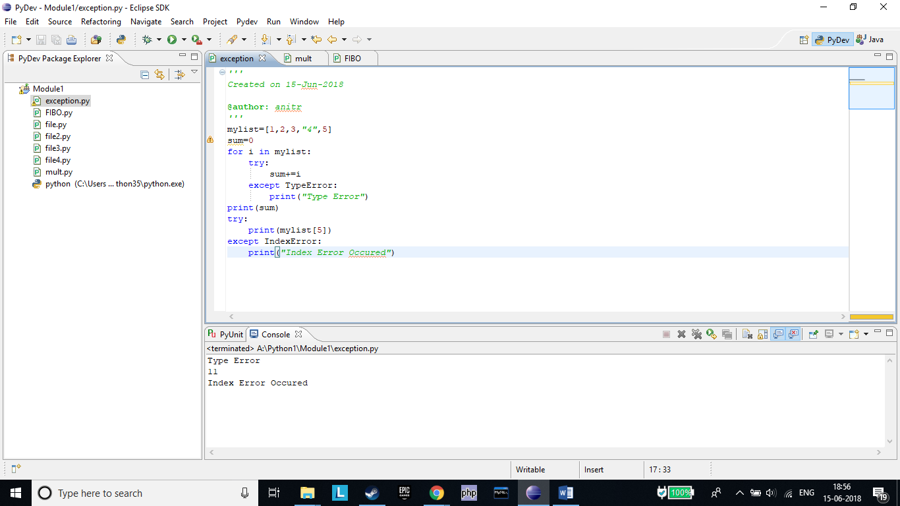

***Assignment 37***

You have already created a Python program to implement the following in ﬁle handling section:

1.read a ﬁle.

2.add backslash (\) before every double quote in the ﬁle contents.

3.write it to another ﬁle in the same folder.

4.print the contents of both the ﬁles.

Modify your code to implement Exception handling. Print appropriate error messages wherever applicable

#

try:

f=open(*"C:\\Users\\anitr\\Desktop\\testfile1.txt"*,*"r+"*)

data = f.read()

print(data)

except FileNotFoundError:

print(*"FileNotFoundError\n File Not FOUND"*)

else:

f1=open(*"C:\\Users\\anitr\\Desktop\\testfile2.txt"*,*"w+"*)

f1.write(data.replace(*'\"'*, *'\\\"'*))

f1.close()

f.close()

try:

f2=open(*"C:\\Users\\anitr\\Desktop\\testfile2.txt"*,*"r+"*)

except FileNotFoundError:

print(*"FileNotFoundError\n File Not FOUND"*)

else:

data2=f2.read()

print(data2)

f2.close()

#

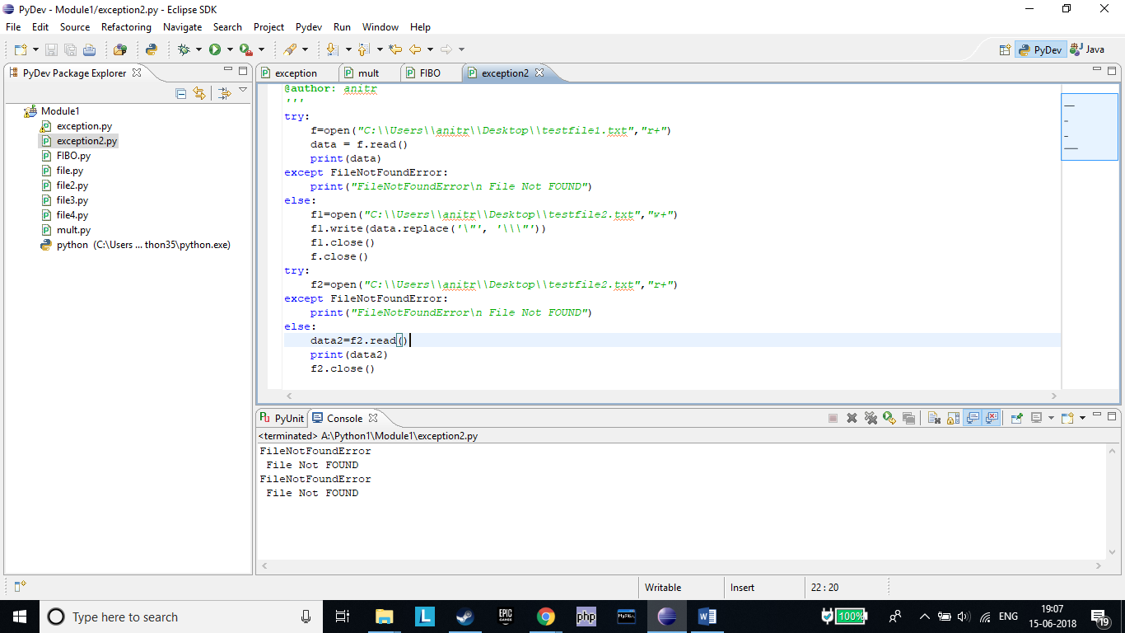

***Assignment 38***

You have already executed the Python program given below in Functions section:

•Add natural numbers up to n where n is taken as an input from user.

Do appropriate exception handling in the code and observe the output by providing invalid input values.

#

try:

num=int(input(*"ENTER NUMBER\n"*))

except:

print(*"ERROR!!!\nENTER A NATURAL NUMBER ONLY"*)

else:

x=0

sum=0

while x<=num:

sum+=x

x+=1

print(*"SUM IS "*,sum)

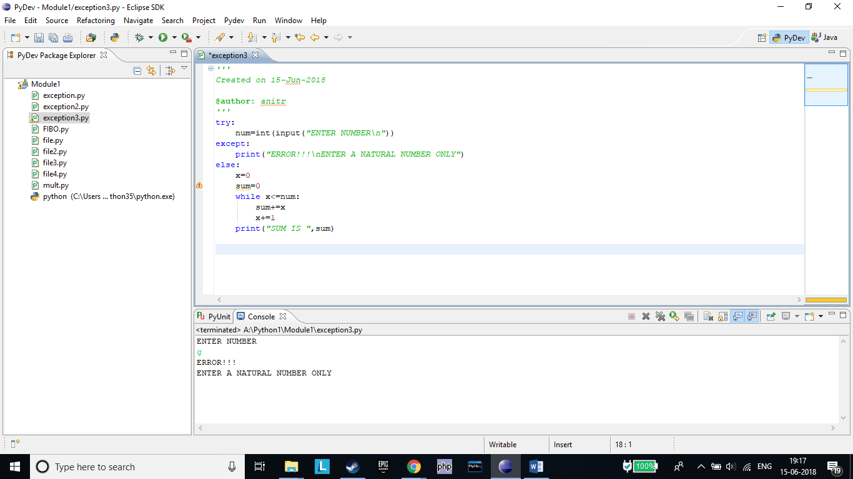

***Assignment 39***

Refer to the following assignment which you have already executed in Functions section. Modify your code to

implement Exception Handling and display appropriate error message wherever applicable.

At an airport, a traveler is allowed entry into the ﬂight only if he clears the following checks:

1.Baggage Check

2.Immigration Check

3.Security Check

The logic for the check methods are given below:

check_baggage (baggage_weight)

•returns True if baggage_weight is greater than or equal to 0 and less than or equal to 40. Otherwise returns False.

check_immigration (expiry_year)

•returns True if expiry_year is greater than or equal to 2001 and less than or equal to 2025. Otherwise returns False.

check_security(noc_status)

•returns True if noc_statusis 'valid' or 'VALID', for all other values return False.

traveler()

•Initialize the traveler Id and traveler name and invoke the functions check_baggage(), check_immigration() and

check_security() by passing required arguments.

•Refer the table below for values of arguments.

•If all values of check_baggage(), check_immigration() and check_security() are true, display traveler_id and traveler_name

display "Allow Traveler to ﬂy!" Otherwise,display traveler_id and traveler_namedisplay "Detain Traveler for Re-checking!“

Invoke the traveler() function. Modify the values of diﬀerent variables in traveler() function and observe the output

#

def **check_baggage** (baggage_weight):

if (baggage_weight>=0) & (baggage_weight<=40):

return True

else:

return False

def **check_immigration**(expiry_year):

if (expiry_year>=2001) & (expiry_year<=2025):

return True

else:

return False

def **check_security**(noc_status):

if (noc_status==*'valid'*) | (noc_status==*'VALID'*):

return True

else:

return False

def **traveler**():

try:

traveler_id=int(input(*"ENTER TRAVELER ID \n"*))

except ValueError:

print(*"VALUE ERROR!!!\n NUMBER ONLY"*)

traveler_name=input(*"ENTER TRAVELER NAME \n"*)

try:

baggage_weight=int(input(*"ENETR BAG WEIGHT\n"*))

except ValueError:

print(*"VALUE ERROR!!!\n NUMBER ONLY"*)

try:

expiry_year=int(input(*"ENETR TRAVEL YEAR\n"*))

except ValueError:

print(*"VALUE ERROR!!!\n NUMBER ONLY"*)

noc_status=input(*"ENETR NOC STATUS(VALID)\n"*)

if(check_baggage (baggage_weight) is True)&(check_immigration(expiry_year) is True)&(check_security(noc_status) is True):

print(*"CUSTOMER ID: "*,traveler_id)

print(*"CUSTOMER NAME: "*,traveler_name)

print(*"ALLOW TO FLY"*)

else:

print(*"CUSTOMER ID: "*,traveler_id)

print(*"CUSTOMER NAME: "*,traveler_name)

print(*"DETAIN TRAVELER FOR RE-CHECK"*)

traveler()

#

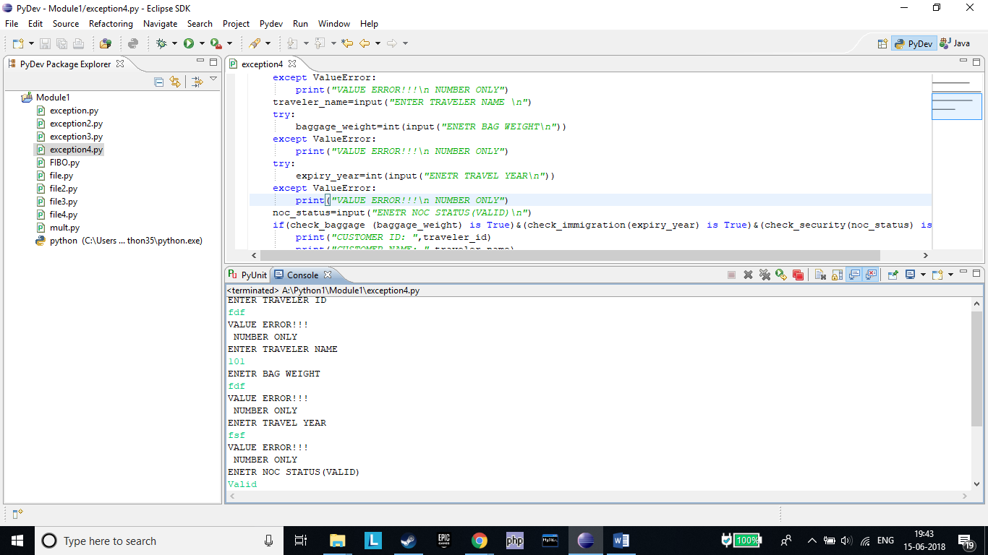

***Assignment 40***

•Create a module "number_checker.py" which has following 2 functions:

•is_prime(num) : this function returns true if the input number is prime

•is_even(num): this function returns true if the input number is even

•Create another Python module "test_module.py".

•Invoke the functions "is_prime(num)" and "is_even(num)" in "test_module.py".

•Observe the results.

Hint: Import "number_checker.py" module in "test_module.py" before using it's functions.

Number_checker.py

#

def **is_prime**(num):

if num > 1:

for i in range(2,num):

if (num % i) == 0:

print(num,*"is not a prime number"*)

break

else:

print(num,*"is a prime number"*)

break

else:

print(num,*"is not a prime number"*)

def **is_even**(num):

if(num%2==0):

print(num,*" IS EVEN"*)

else:

print(num,*" IS ODD"*)

#

Test_module.py

#

import number_checker

n=int(input(*"ENTER NUMBER \n"*))

number_checker.is_even(n)

number_checker.is_prime(n)

#

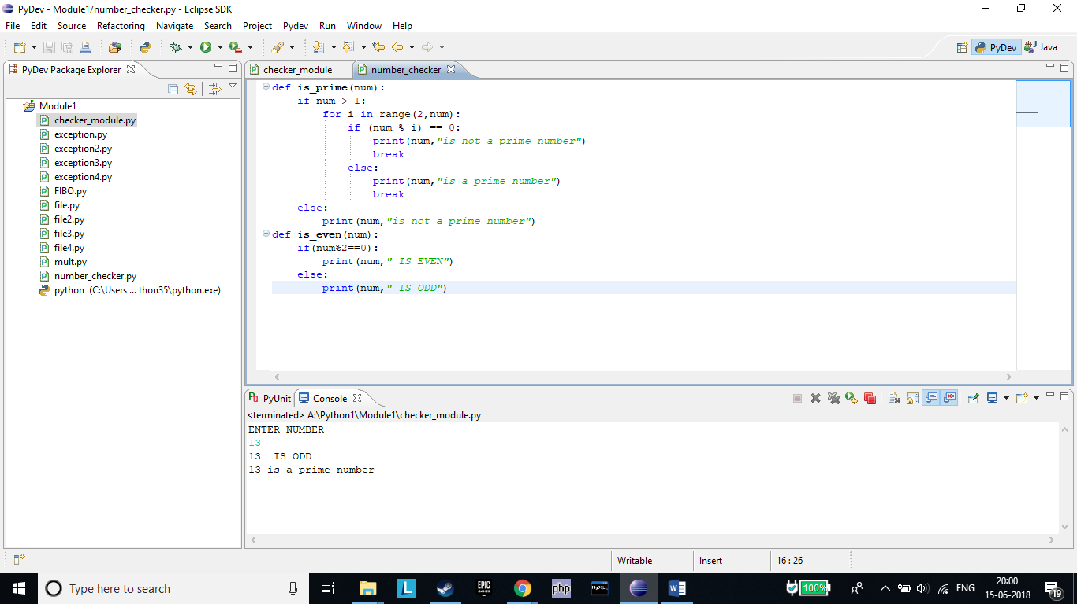

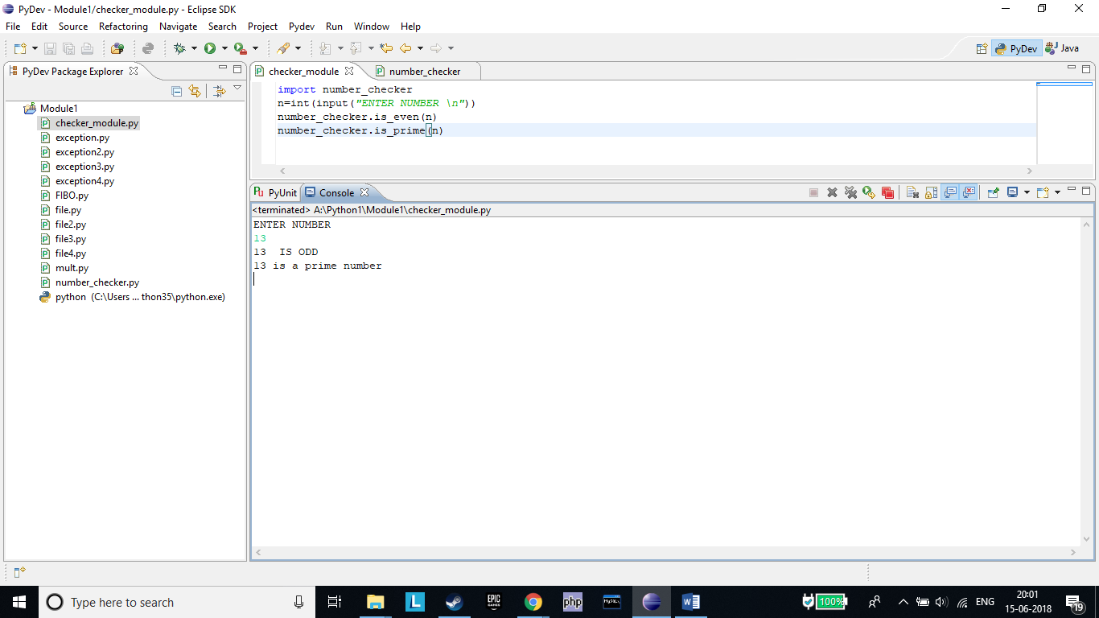

***Assignment 41***

•Write a Python program to randomly print any of the below numbers:

100,200,300,400,500,600,700,800,900,1000

Execute the program 10 times and verify if the number generated in every output is one out of the numbers given in the list above.

#

import random

x=random.randrange(100,1000,100)

print(x)

#

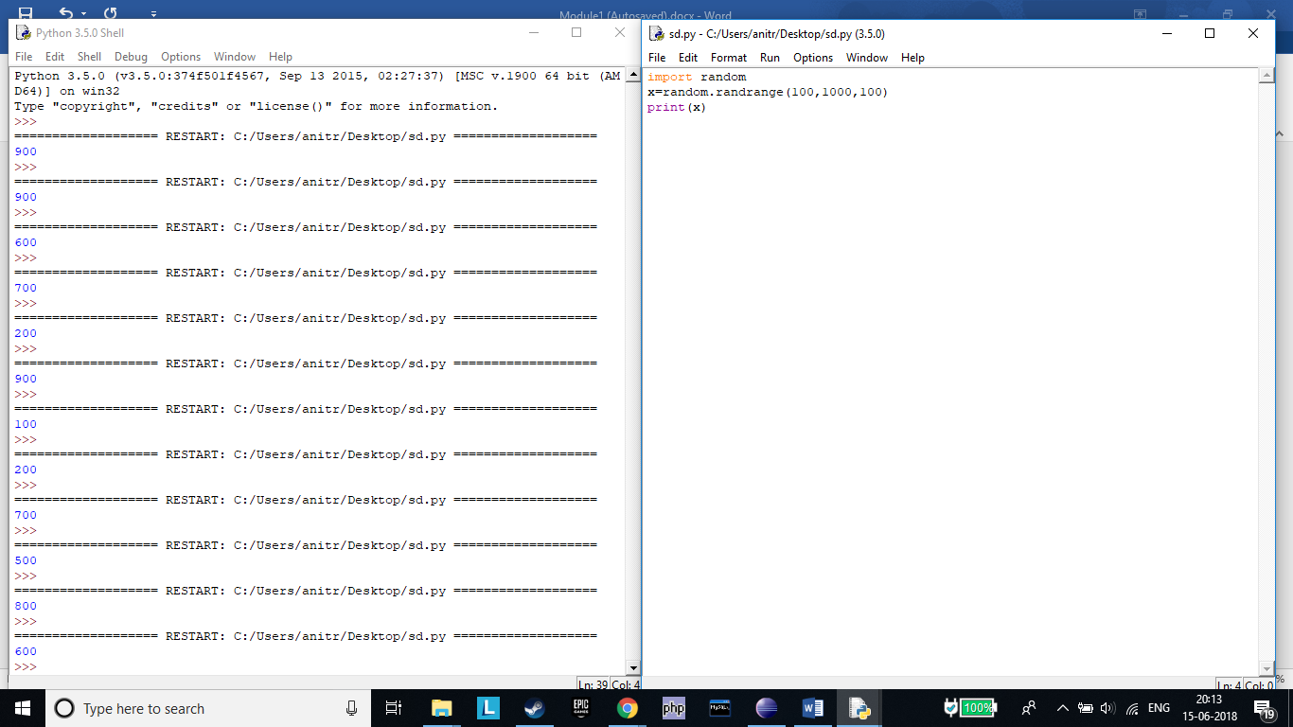

•Write a Python program to print a random odd numbers between 10 and 50.

#

import random

x=random.randrange(11,50,2)

print(x)

#

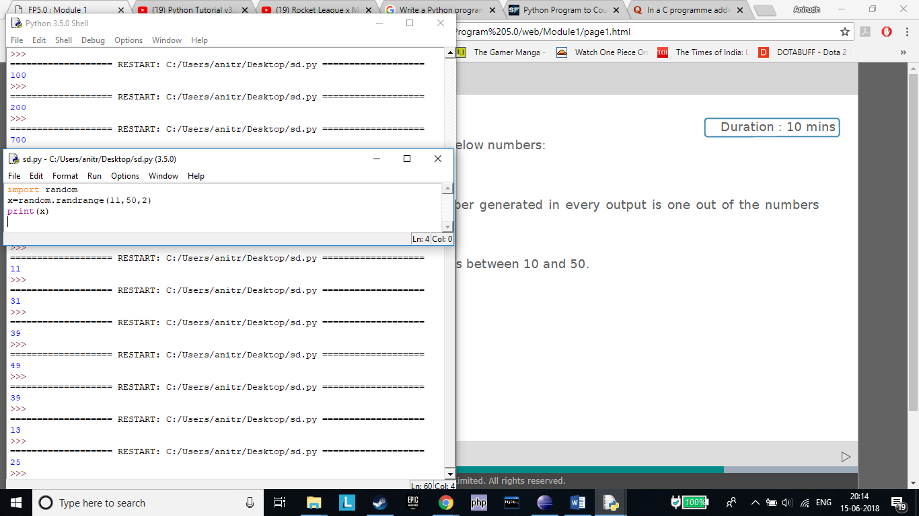

***Assignment 42***

Write a Python program for rolling a dice on clicking enter key. The program should run inﬁnitely until user enters 'q'.

Hint: To implement a dice, you can randomly print a number in the range 1-6.

#

import random

leave=0

while leave!='q':

print("PRESS ENTER TO ROLL DICE")

input()

print(random.randint(1,6))

print("ENTER Q TO EXIT")

leave=input()

#

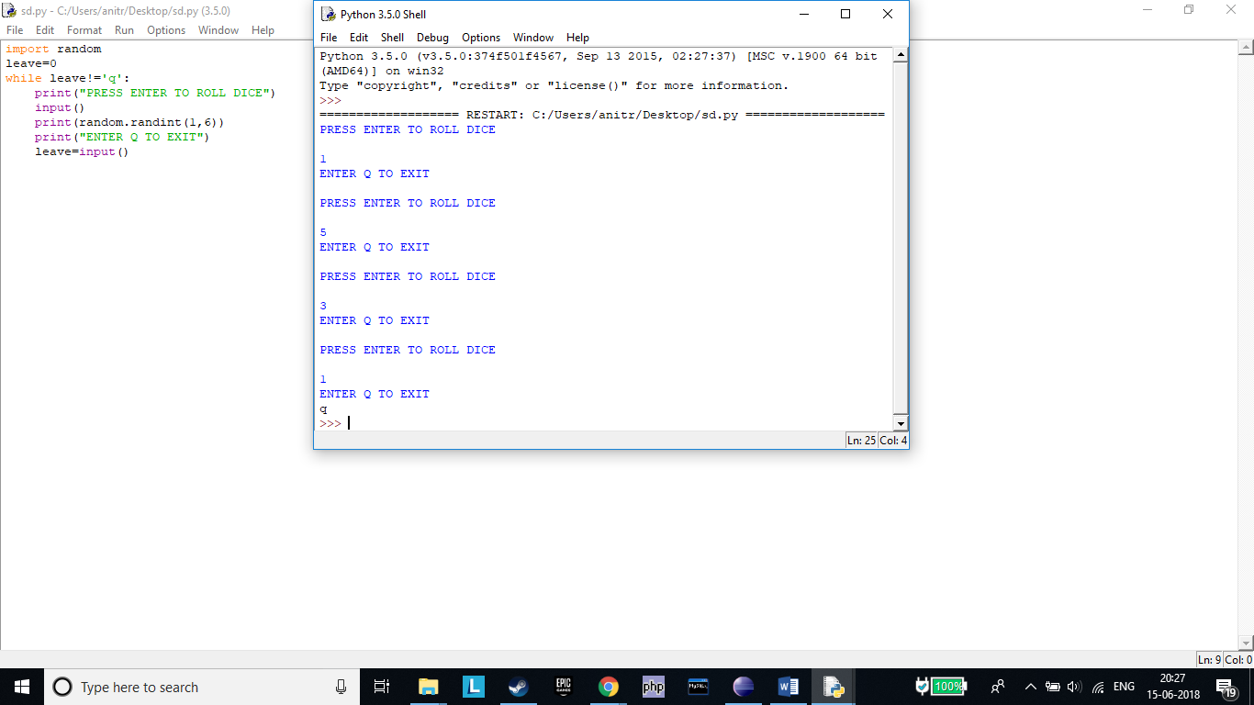

***Assignment 43***

If area of one wall of a cubical wooden box is 16 units, write a Python program to display the volume of the box.

Note:

Area of a cube with side 'a' is 'a**2'.

Volume of the cube can be computed as 'a**3'.

Hint: Make use of 'sqrt' and 'pow' functions from math module.

#

import math

ar=16

l=math.sqrt(ar)

print("AREA OF A SIDE OF CUBE ",ar)

print("SIDE OF CUBE IS ",l)

arc=6*math.pow(l,2)

vol=math.pow(l,3)

print("AREA OF CUBE IS ",arc)

print("VOLUME OF CUBE IS ",vol)

#

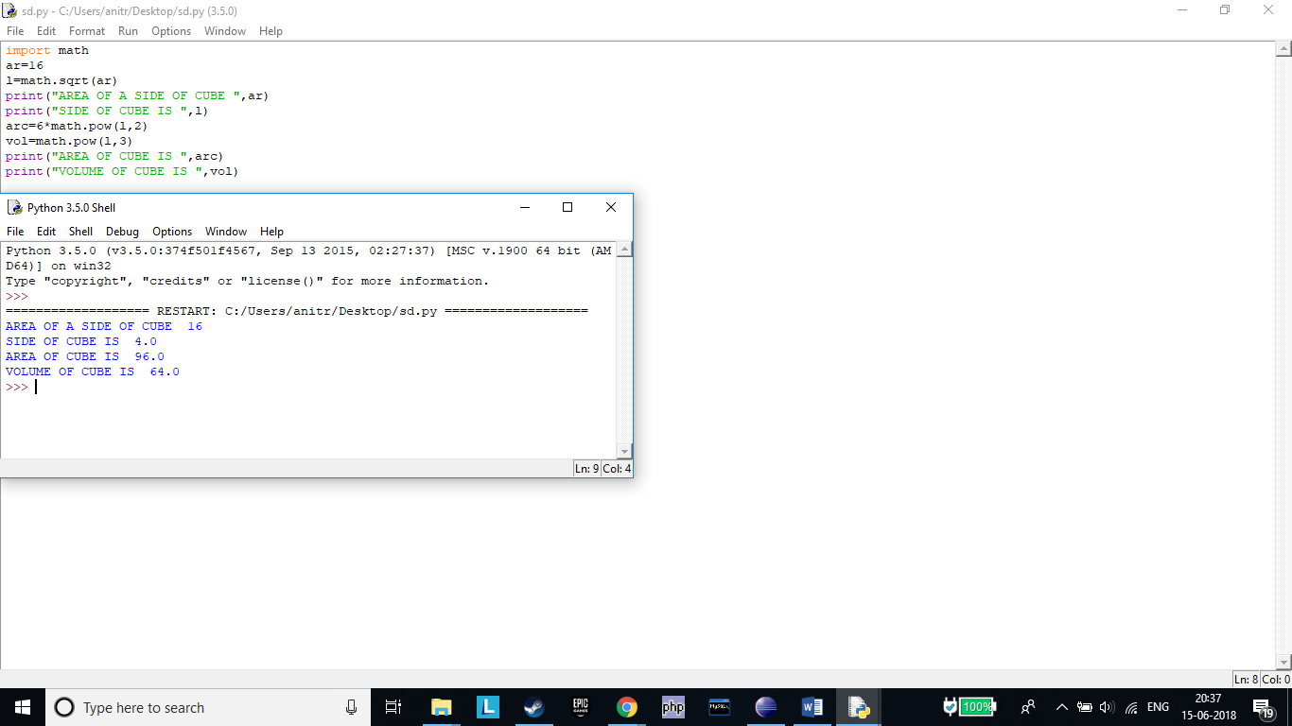

***Assignment 44***

The ABC Institute oﬀers vocational courses to students in multiple areas e.g. theatre, classical singing, traditional dance forms, Bollywood dance, literature and so on. A student can enroll for zero to all courses.

Write a Python function that takes the number of courses as an input and returns the total number of diﬀerent course combinations, a student can opt for. (Make use of functions available in math module)

Hint: if no_of_courses = 2, possible number of combinations are 2! i.e. 2if no_of_courses = 3, possible number of combinations are 3! i.e. 6 and so on.

#

import math

num=int(input("ENTER THE NUMBER OF COURSES ENROLLED IN "))

x=math.factorial(num)

print("POSSIBLE COURSE COMBINATIONS ARE ",x)

#

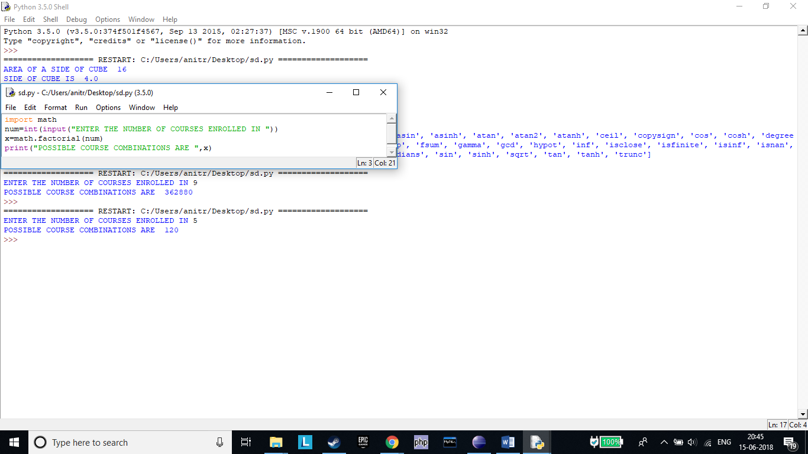

***Assignment 45***

Execute the following code and observe the output.

1.import time

2.print(time.time())

3.print(time.localtime())

4.print(time.localtime(time.time()))

5.print(time.asctime())

6.mytime = (2016,7,27,15,45,23,0,0,0)

7.print(time.localtime(time.mktime(mytime))

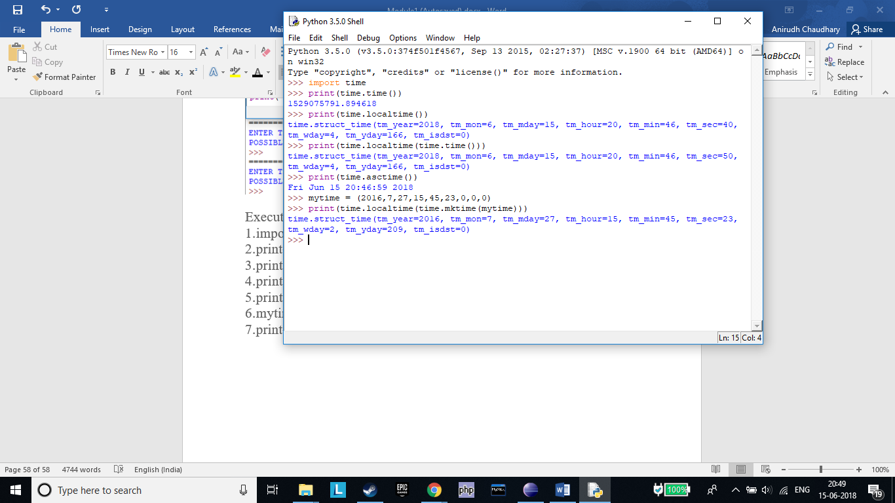

***Assignment 46***

Consider a Python string:

cust_details = "Hello John, your customer id is j181"

1)Find, if the name of the customer is preceded by a pattern "Hello " or "hello " (Observe a space after the word)? If pattern is found, print the searched result.

2)Find, if the given string ends with a pattern containing only one alphabet followed by three numbers? If pattern is found, print the searched result.

3)Replace the word starting with "j" followed by three numbers to only the number(remove the alphabet).

4)Replace the word "id" with "ID". The output of the above code is "Hello John, your customer ID is 181"

#

import re

cust_details = "Hello John, your customer id is j181"

matched=re.search("Hello ",cust_details)

print(matched.group())

#matched=re.search("hello ",cust_details)

#print(matched.group())

matched=re.search("j\d{3}",cust_details)

print(matched.group())

new_str=re.sub("j","",cust_details)

print(new_str)

final_str=re.sub("id","ID",new_str)

print(final_str)

#

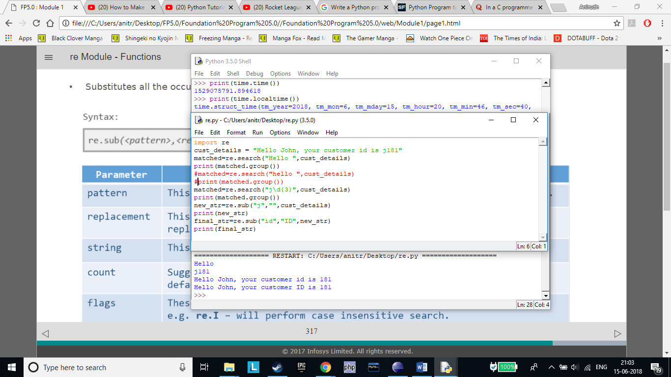

***Assignment 47***

Consider a scenario of managing student details in ABC Training Institute. Write a Python program to implement the

business requirements mentioned below:

a)Accept student_id and validate whether it contains only digits.

b)If student _id is valid, accept student_name from the user and validate whether it contains only alphabets.

c)If student_name is valid, accept fees_amount paid by the student:

1.Decimal point is optional in fees_amount(can have maximum one decimal point)

2.Only two digits are allowed after decimal point

d)If invalid data is entered in any of the above steps, display appropriate error messages. Else, create an email_id for student as

student_name@ABC.com. Assume there are no duplicate names.

e)Perform above validations using Regular Expressions and print details of the student: student_id, student_name, fees_amount, email_id

#

student_id=input("ENTER STUDENT ID(DIGITS ONLY\n")

if(student_id.isdigit()):

student_name=input("ENTER STUDENT NAME \n")

if(student_name.isalpha()):

fees_amount=float(input("ENTER FEE AMOUNT\n"))

email_id=student_name+'@ABC.com'

print("STUDENT ID:",student_id)

print("STUDENT NAME:",student_name)

print("STUDENT FEE AMOUNT:",round(fees_amount,2))

print("STUDENT MAIL ID:",email_id)

else:

print("DIGIT WAS ENTERED IN NAME")

else:

print("ERROR A CHARACTER WAS INSERTED")

#

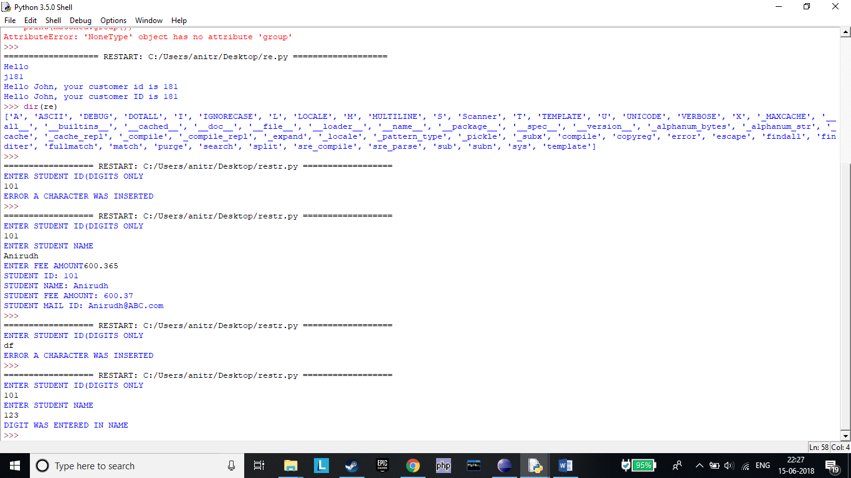

***Assignment 48***

Consider a string:

my_string = “””Strings are amongst the most popular data types in Python. We can create the strings by enclosing characters in quotes. Python treats single quotes the same as double quotes.”””

1) Write a Python program to count the number of occurrences of word "String" in the given string ignoring the case.

2) Write a function "count_words" to print the count of occurrences of a word:

a) which end with "on". (e.g. Python)

b) which have "on" in between the ﬁrst and last characters (e.g. amongst)

#

my_string = "Strings are amongst the most popular data typesin Python. We can create the strings by enclosing characters in quotes. Pyt0hon treats single quotes the same as double quotes."

print(my_string)

string=my_string.lower()

word=input("Enter word:")

a=[]

count=num=0

a=string.split(" ")

for i in range(0,len(a)):

if(word==a[i]):

count=count+1

print("Count of the word is:",count)

k=string.split(" ")

l='on'

for j in range(0,len(k)):

if(l==k[i]):

num=num+1

print("Count of the word containing on:",num)

#

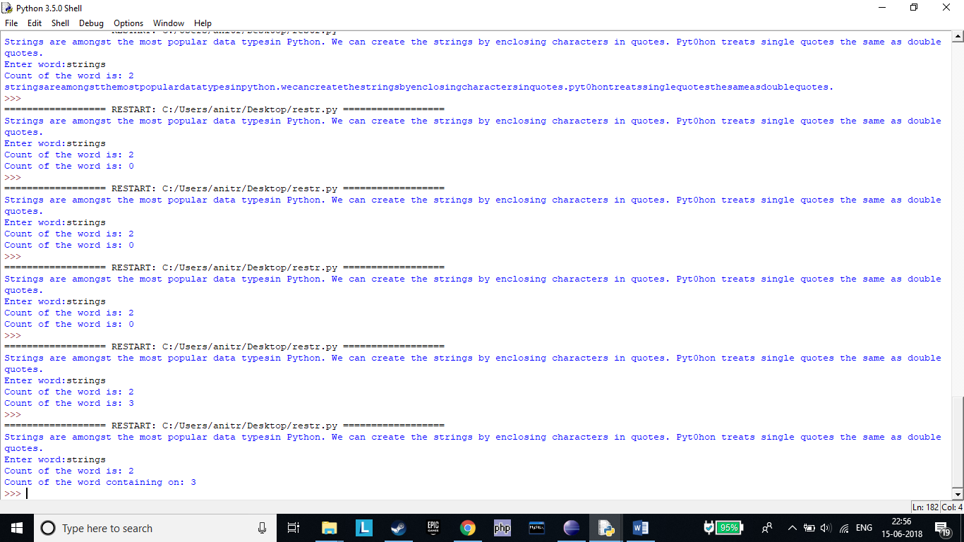

***Assignment 49***

Consider the price list of various items in the Retail Store:

item_price = [1050, 2200, 8575, 485, 234, 150, 399]

Customer John wants to know the:

1.Price of costliest item sold in retail store

2.Number of items in the Retail store

3.Prices of items in increasing order

4.Prices of items in descending order

Implement the above mentioned business requirements using built-in List functions.

Hint –

1) Use max, len, sort functions of math module.

2) For question 3 and 4, display the list in increasing/decreasing order.

#

item_price = [1050, 2200, 8575, 485, 234, 150, 399]

print(max(item_price))

print(len(item_price))

print(sorted(item_price))

print(sorted(item_price,reverse=True))

#

